Quality

User Guide

2001 Census Public Use Microdata File (PUMF)

Families File

Table of Contents

Page
1. INTRODUCTION 3
2. OPENING THE APPLICATION 4
3. USING THE APPLICATION 5
A. Geographic Area 5
Inserting a geographic area in the list 5
Deleting a geographic area from the list 6
B. Variable 7
Inserting a variable in the list 7
Deleting a variable from the list 11
C. Calculations 12
Nominal variables 12
Numerical variables 12
4. RESULTS 14
A. Dialogue Box 14
B. Excel Worksheet 15
C. Saving Your Results 15
5. ERROR MESSAGES 16
6. HELP 19
7. MACINTOSH VERSION OF QUALITY 21

1. INTRODUCTION

In Chapter III of the Public Use Microdata Files (PUMFs) documentation, various ways of computing the coefficient of variation are proposed. One of them is the use the Quality application. This application is an Excel worksheet to which have been added controls such as command buttons, list boxes and text boxes. Consequently, a version of Excel is needed to use the Quality application. Quality measures the sampling error for estimates from Public Use Microdata Files.

The Quality application requires fewer calculations by the user than other methods of computing the coefficient of variation. The user simply selects the desired variables and geographic areas and provides other necessary information. The Quality application takes care of the calculations. The results are displayed in a dialogue box and an Excel worksheet.

Note that this guide is specifically designed for users of the personal computer (PC) version of the Quality application. Since a Macintosh (Mac) version, very similar to the PC version, is available, this guide also provides directions for Mac users.

It provides step-by-step instructions on how to use the application. It explains how to insert geographic areas and variables and how to save the results. Moreover, Section 7 contains user information on the Mac version of Quality.

The application can only process one estimate at a time. In this Guide, we will be using Example 3 from Chapter III of the PUMF documentation.

We will calculate the coefficient of variation associated with the proportion of families living in common-law with children relative to the total number of families consisting of a couple in the Vancouver census metropolitan area (CMA).
2. OPENING THE APPLICATION

The application is on the CD-ROM, in the “ENGLISH\Excel” directory. Copy the application on your hard disk. To open Quality, double-click the file named “Quality.xls”. Choose the “Enable Macros” option from the dialog box to enable the application’s functions.

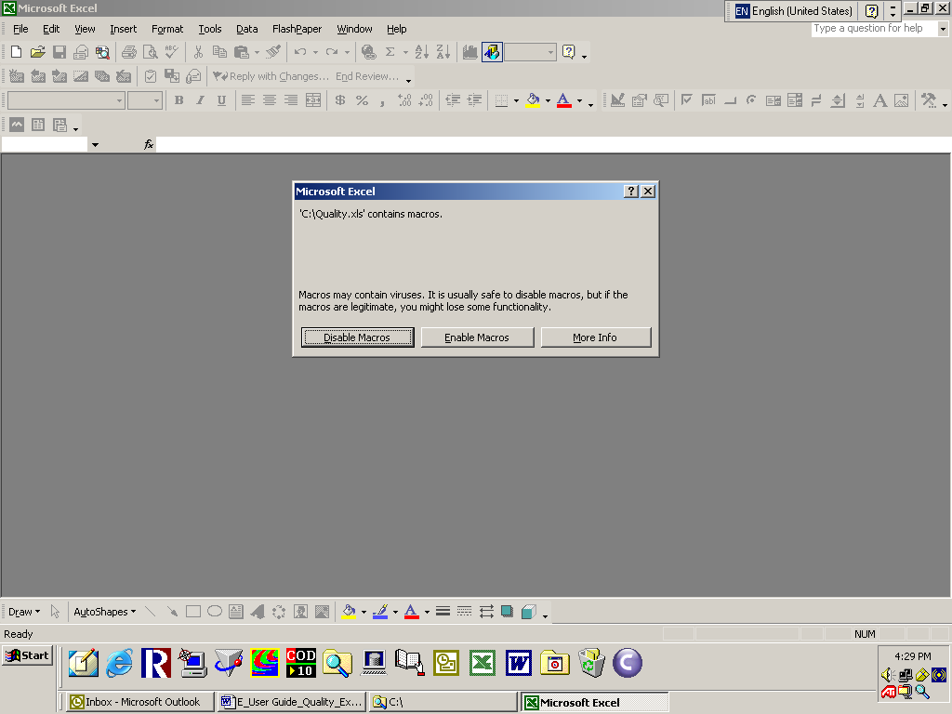

3. USING THE APPLICATION

To compute your estimates’ coefficient of variation, you will first have to calculate the number of records that meet the characteristics required by the query. If your estimates involve a numerical variable, you will have to compute its mean and standard deviation using a statistical application or a spreadsheet, then insert, in Quality, what geographic areas and variables were used in producing your estimates. Afterwards, the Quality application will take care of the calculations.

A. Geographic Area

Inserting a geographic area in the list

To insert a geographic area in the “List of Geographic Areas” box, select it in the dropdown list of the “Select a geographic area” box using the mouse or the keyboard. Then click “Add >”. The geographic area will appear in the “List of Geographic Areas” box.

It is possible to insert more than one geographic area at a time. Using the mouse, select the first geographic area in the dropdown list of the “Select a geographic area” box. Then, while holding the “Control” key pressed down, select the other desired geographic areas. When all the desired geographic areas are highlighted, click the “Add >” button located at the right of the “Select a geographic area” box.

In this example, the Atlantic provinces have been selected.

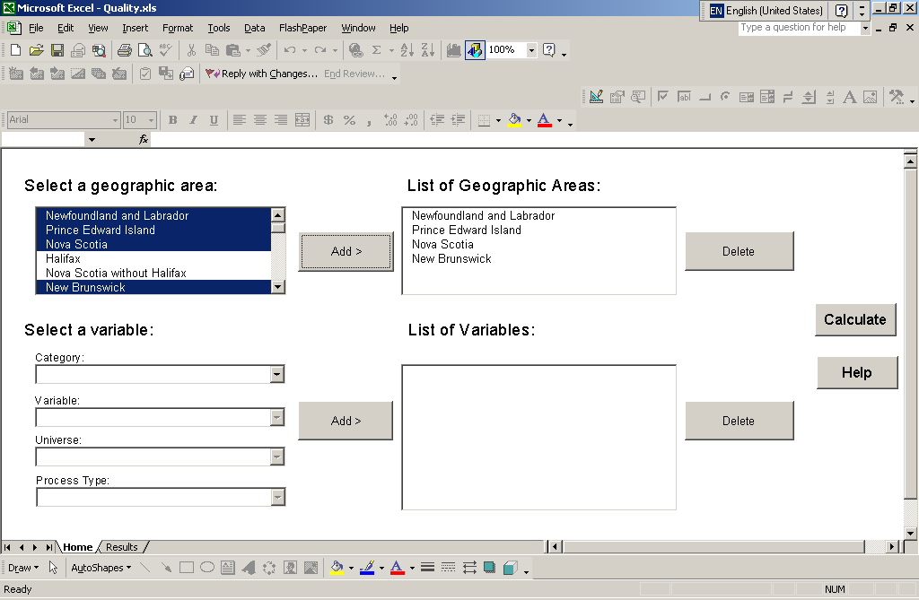

Deleting a geographic area from the list

To delete a geographic area from the “List of Geographic Areas” box, select it in the list using the mouse or the keyboard and click “Delete”. It will then disappear from the “List of Geographic Areas” box.

It is possible to delete more than one geographic area at a time. Using the mouse, select the first geographic area to be deleted in the “List of Geographic Areas” box. Then, while holding the “Control” key pressed down, select the other geographic areas to be deleted. When all the geographic areas to be deleted are highlighted, click the “Delete” button located at the right of the “List of Geographic Areas” box.

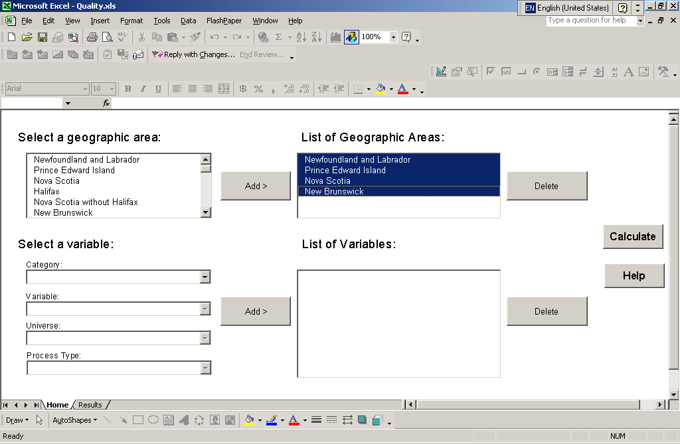

B. Variable

Inserting a variable in the list

To insert a variable in the “List of Variables” box, first select the variable’s category from the “Category” dropdown list. In this example, we chose the “Families and Family Composition” category.

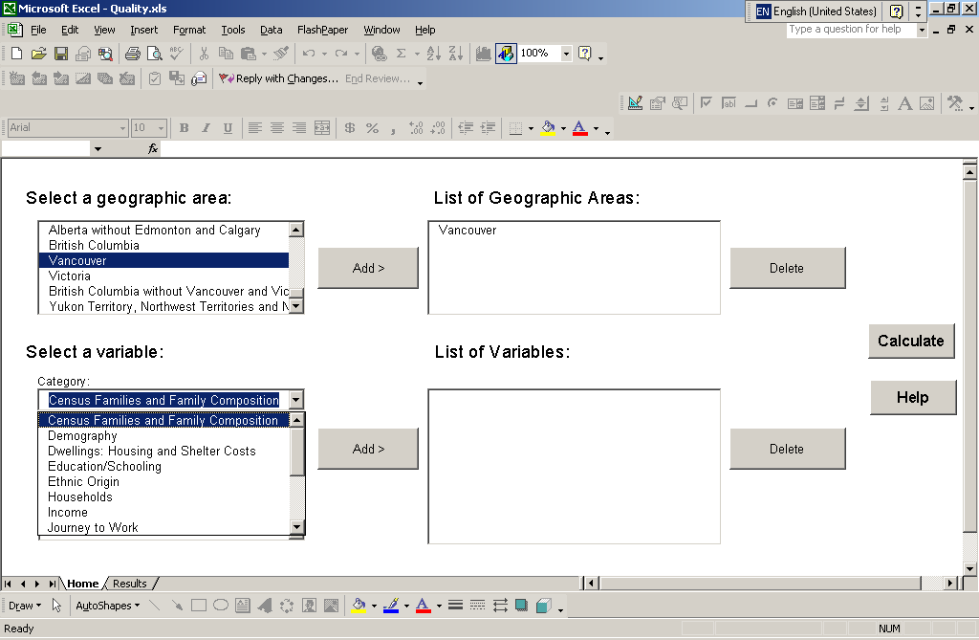

Then select the mnemonic of the desired variable. To illustrate this, we chose the census family structure variable.

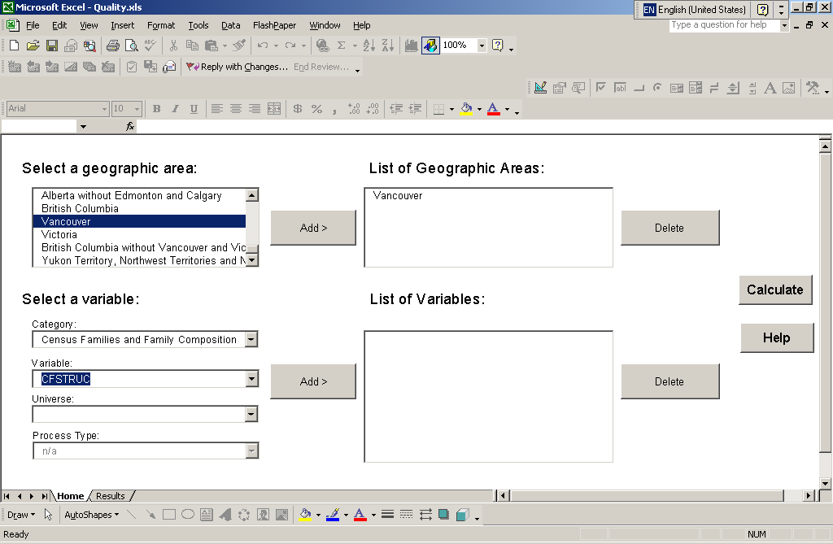

We have to choose the proper universe for the desired estimate: either the census family universe or the non-census family person universe. In Example 3, we selected the census family universe, because we want to estimate the proportion of families consisting of a couple living in common-law with children.

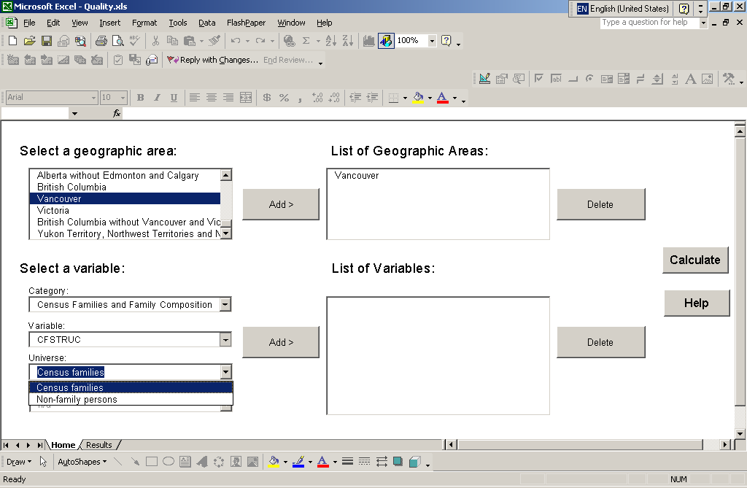

If the variable is numerical, select its process type: either numerical or nominal. The type of treatment depends on the chosen estimate. If it is the mean or another statistic that must be computed using the value of the variable, the numerical process is chosen. If the variable is nominal, do not select a process type. The value n/a will be assigned automatically. In Example 3, there was no choice, since the census family structure variable is not numeric. The value n/a is assigned automatically.

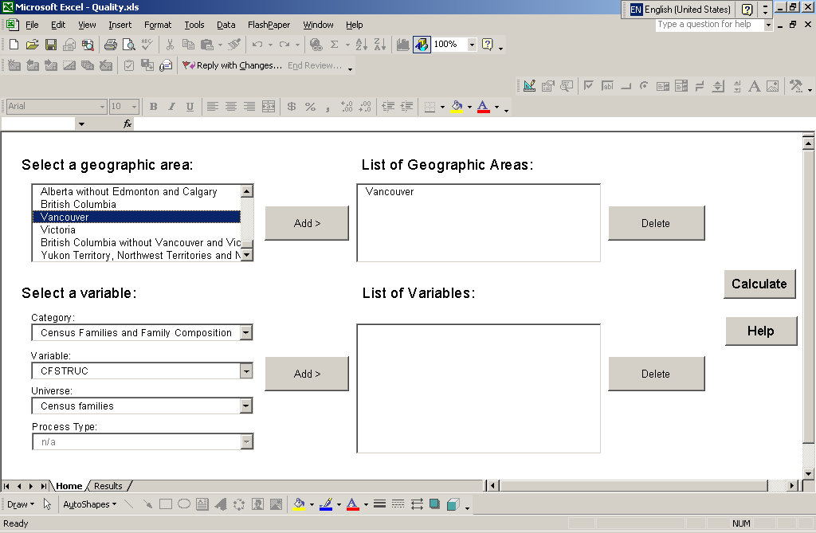

Click “Add >” to add the variable to the list. It will appear in the “List of Variables” box.

Note: Only one numerical variable can be processed as numerical per query. You will have to process the other variables of a query as nominal variables.

Deleting a variable from the list

To delete a variable from the “List of Variables” box, select it in the list using the mouse or the keyboard and click “Delete”. It will then disappear from the “List of Variables” box.

It is possible to delete more than one variable at a time. Using the mouse, select the first variable to be deleted in the “List of Variables” box. Then, while holding the “Control” key pressed down, select the other variables to be deleted. When all the variables to be deleted are highlighted, click the “Delete” button located at the right of the “List of Variables” box.

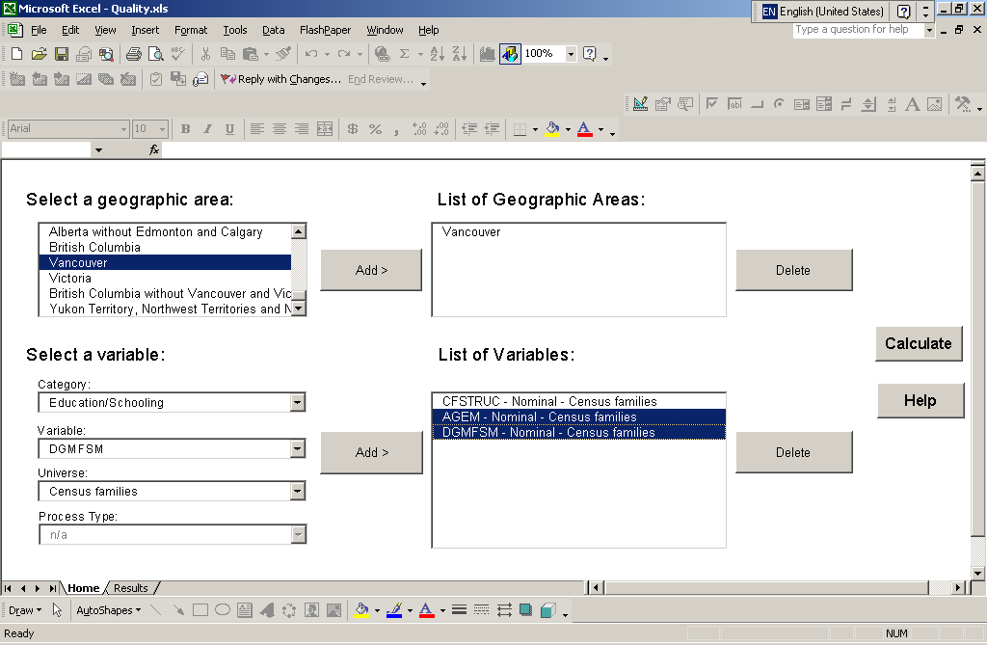

C. Calculations

After selecting the geographic areas and variables, click “Calculate”. Various dialog boxes will appear, depending on the selected variables.

Nominal variables

If you selected only nominal variables or variables treated as nominal variables, enter the number of records in the text field of the dialog box and click “OK”.

Numerical variables

If you selected a numerical variable, enter its mean in the first text box and its standard deviation in the second box. Click “OK”.

If you have the sampling coefficient of variation but not as a percentage, enter “1” in the first text field and the sampling CV in the second field. Click “OK”.

If you have the sampling coefficient of variation as a percentage, multiply it by 100. Enter “1” in the first text field and the result of the multiplication in the second field. Click “OK”.

Another dialog box will appear, asking you to verify the mean and standard deviation you entered. Click “Accept” if the inputs are correct. Click “Decline” if the mean and standard deviation are incorrect. The previous dialog box will reappear. You can then make the necessary changes.

Next, enter the number of records in the text box of the new dialog box and click “OK”.

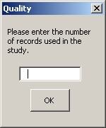

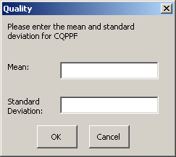

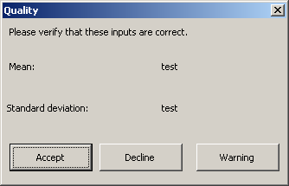

For Example 3, we have to run two queries. First, for the numerator, we include only the Vancouver CMA in the “List of Geographic Areas” box. Second, we include only the following mnemonic in the “List of Variables” box:

CFSTRUC – Nominal – Census Families

For the numerator, we enter the number of records of families consisting of a couple living in common-law with children in the Vancouver CMA – 397.

For the denominator, we enter the number of records of families with children in the Vancouver CMA – 7,122.

4. RESULTS

A. Dialogue Box

After the calculation is done, a dialog box will appear with the results. The category, the interval containing the coefficient of variation and an approximation of the coefficient of variation will be displayed. Click “Finish” to return to the “Home” worksheet.

For the numerator, the result is:

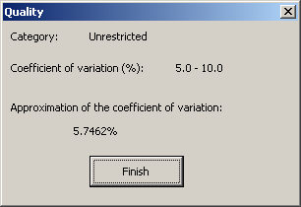

For the denominator, the result is:

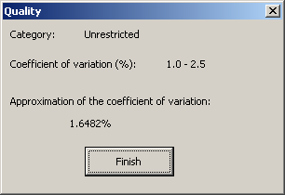

The highest of the two results, that is, the result obtained for the numerator, must be selected.

The Quality application uses the Excel worksheet method. If the results obtained with the Excel worksheet method are compared to those obtained with the Table 1 method, slight differences can be observed.

B. Excel Worksheet

To view the detailed results, select the “Results” tab at the bottom of the screen. The “Results” Excel worksheet will appear. In addition to the results provided in the dialogue box, this worksheet will show the quality factors associated with the selected variables for each geographic area in the “List of Geographic Areas” box. The worksheet also enables you to copy the results of the query to a file.

The results for the numerator can be seen below.

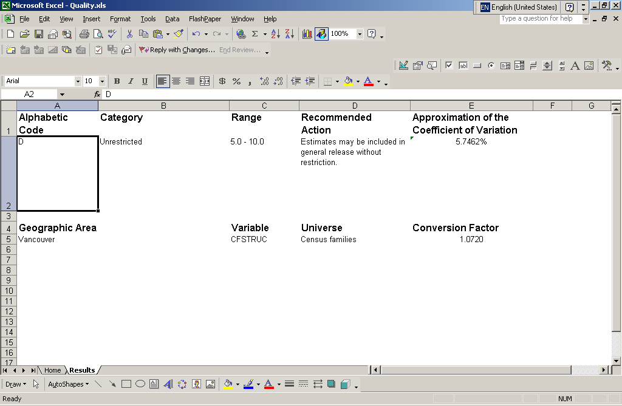

Note: When a variable is degenerate, that is, when all the records have the same value, the conversion factor shown is -1. In Appendix B, the code for a degenerate variable is indicated by the XXX value.

C. Saving Your Results

If you want to save the query results shown on screen, select them with the mouse and copy the selection. Open another Excel workbook, and paste the data into a new worksheet. Save the new workbook. Then select the “Home” tab to run another query.

If you run another query before saving the results shown in the “Results” worksheet on the screen, they will be replaced by the results of the new query.

5. ERROR MESSAGES

When you run a query, the following error messages may appear on the screen:

This message appears when you click “Calculate” without entering a geographic area in the “List of Geographic Areas” box. Click “OK” to return to the “Home” worksheet and select a geographic area. |  | 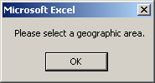
This message appears when you click “Calculate” without entering a variable in the “List of Variables” box. Click “OK” to return to the “Home” worksheet and select the variables of interest. |  | 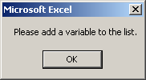
This message appears when you click “Add >” while one or more of the variable fields are still blank. Click “OK” to return to the “Home” worksheet and fill in the blank fields. |  | 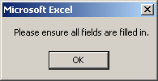
This message appears when you select more than one numerical variable and click “Calculate”. Click “OK” to return to the “Home” worksheet and delete the excess numerical variables. |  | 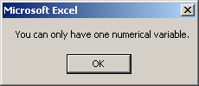
This message appears when you enter non-numerical characters or “0” in the spaces provided for the capture of the mean. Click “OK” to return to the input window and enter the proper value.  This message also appears when you enter “0” in the space provided for the number of records. Click “OK” to return to the input window and enter the proper value. |  | 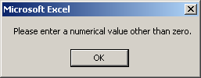
This message appears when you enter non-numeric characters in the spaces provided for the number of records, the mean or the standard deviation. Click “OK” to return to the input window and enter the proper value.  Note: Operations (e.g. 124*36) are not considered numerical. |  | 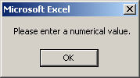
One of these messages appears when you click the active “Warning” button in the mean and standard deviation confirmation window. It means that there are non-numerical characters in the spaces for the mean or the standard deviation or that the mean entered is null. Click “Cancel” to return to the confirmation window. Then click “Decline” and enter the proper data in the window that appears. |  | 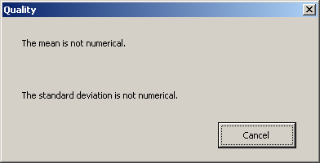  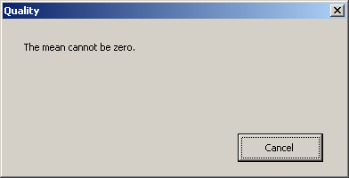
This message will appear if the coefficient of variation is greater than 10 (1,000%). Click “OK” to return to the “Home” worksheet and enter the mean and standard deviation values again. |  | 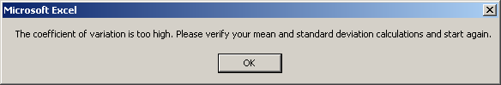
This message will appear if all the variables in the list are degenerate; i.e., each variable has only one value. Click “OK” to return to the “Home” worksheet and add other variables to the list. |  | 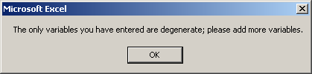
This message appears when the number of records entered is higher than 348,104, which represents the number of records contained in the Families File. Please enter a number of records lower than 348,104. |  | 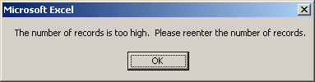

6. HELP

Quality’s help function is a quick way to get step-by-step advice on how to use the application. Simply click “Help” and select the subject and item of interest.

When you click “Help” on the “Home” worksheet, a new window will appear. Of the five categories, choose the one that best fits what you are looking for. The “Geographic area” category deals with the selection of geographic areas in the “Home” worksheet. The “Variable” category concerns the selection of variables in the “Home” worksheet. The “Calculation” category relates to the actions required to calculate the coefficient of variation. The “Results” category covers the ways in which the results are presented. The “Error message” category deals with the various errors you may encounter and how to correct them.

After choosing the category, select the item of interest. An item is a more specific help topic. In general, it refers to the action you want to perform. After selecting a category and an item, click “OK”.

For example, if you want to know how to save your results, first click “Help”. Next, select the “Results” category, and choose the “Save the results” item. Then click “OK”.

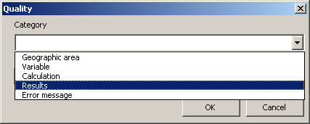

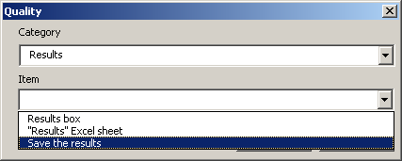
A first dialog box will appear. This first box contains the first of the steps you have to carry out to perform the desired action. Simply click “Next” to go on to the next step. When you complete the desired action, if you want to choose another help item, click “Return”. To return to the “Home” worksheet, click “Finish”.

Unfortunately, you cannot access the help function when input windows or error messages are on the screen. Please read the help item carefully and then perform the desired action.

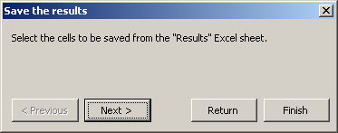

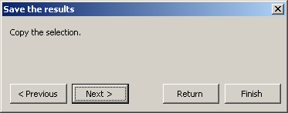

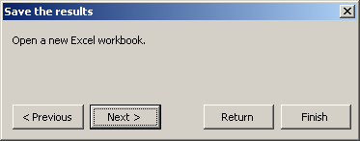

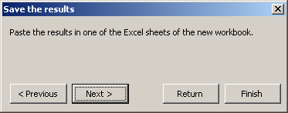

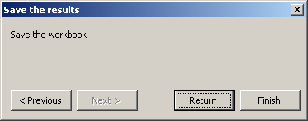

7. MACINTOSH VERSION OF QUALITY

A Mac version of Quality is also available to users of Excel for Mac. The graphical interface of the Mac version of Quality is somewhat different from the PC version, as the buttons and controls appear on a form rather than on an Excel worksheet. However, it works in essentially the same way.

To launch the application, enable the macros. Then select the geographic areas and variables as described in Sections 3A and 3B, and click “Calculate”. Enter the data needed for the calculation, as described in Section 3C. The results will appear in a window. To view the detailed results in the “Results” worksheet, click “Finish”. The main form will close, and you will have access to the “Results” worksheet. The method of saving the results is the same as the one for the PC version of Quality (described in Section 4C). If you want to go back to the main form, click the “Quality” button in the upper left corner of the “Results” worksheet.

For more information on the mean and standard deviation, see Chapter III of the 2001 Census PUMFs user documentation.

