> My results of 2008-09-17 | 

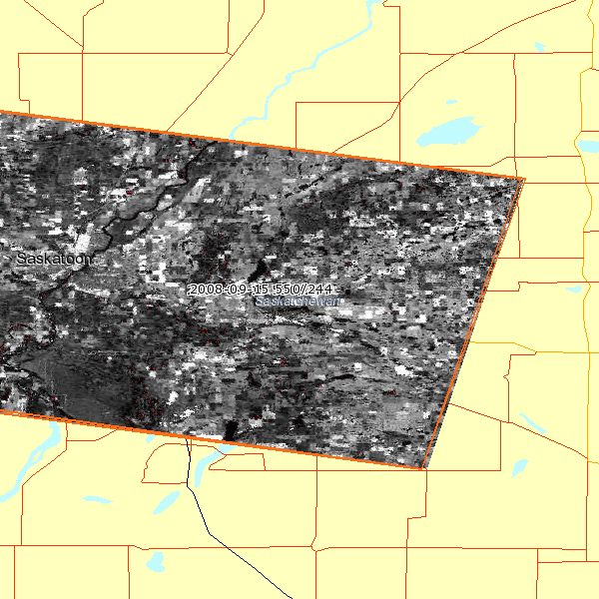
 |  | Area of interest
 |  | Spot scene
 |  | Kompsat-2 scene

Scene reference : 55502440809151746382J 10 m C
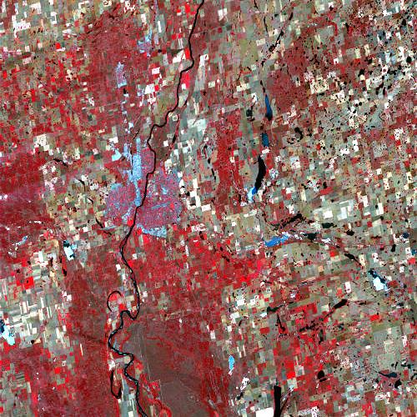 | Satellite : | Spot5
 | K/J : | 550 / 244
 | Acquisition date : | 2008-09-15
 | Cloud % : | 0 %
 | Cloud cover rating : | AAAAAAAA
 | Shift along track (SAT) : | 3
 | Centre : | N52°06 W106°30
 | Angle of incidence : | -28.04°
 | Spectral bands : | 4

Scene reference : 55502440809151746362B 5 m BW
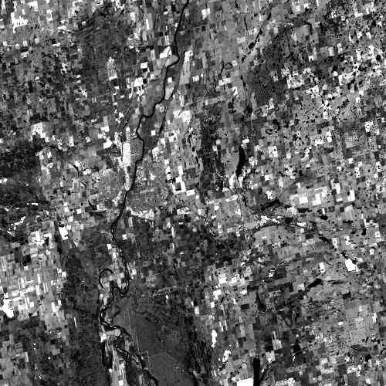 | Satellite : | Spot5
 | K/J : | 550 / 244
 | Acquisition date : | 2008-09-15
 | Cloud % : | 0 %
 | Cloud cover rating : | AAAAAAAA
 | Shift along track (SAT) : | 3
 | Centre : | N52°06 W106°30
 | Angle of incidence : | -28.04°
 | Spectral bands : | 1

