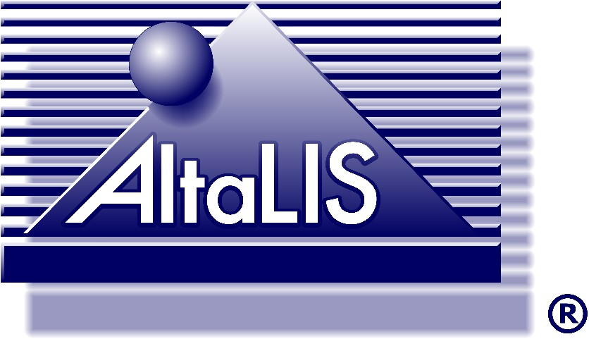
Copyright and License
This digital data is protected under copyright to the Government of Alberta with all rights reserved. Any reproduction, redistribution, or transmission of the data in any form or any means in whole or in part, in its original or any value-added form, is expressly prohibited without the prior written agreement of Spatial Data Warehouse Ltd. The Licensee (person or organization who agrees to this license and downloads the associated data) is granted a non-exclusive and non-transferable license to use this digital data for internal purposes.
The Licensee releases, discharges and does hereby indemnify and hold harmless AltaLIS, SDW, the Crown, and their respective directors, officers and employees from any and all claims, obligations, loss, actions, rights of action, and damages, (including any damages that are indirect, consequential or otherwise) including any arising from any negligence or omission of AltaLIS, SDW, the Crown, or their respective directors, officers and employees or agents that the Licensee may sustain from or in connection with the preparation of, or provision to OR USE by the Licensee of, the Supplied Data and any other DEALINGS, activity or occurrence in respect of the Supplied Data or storage media.

This digital data file may contain errors. Spatial Data Warehouse Ltd., AltaLIS Ltd. and the Government of Alberta disclaim all warranties and conditions with respect to this digital data, including implied warranties of merchantability and fitness for a particular purpose. The Licensee acknowledges and agrees that none of Spatial Data Warehouse Ltd., AltaLIS Ltd. or the Government of Alberta is liable for any damages or loss, including indirect, incidental or consequential damages or loss, which the Licensee may suffer or incur by using this digital data

