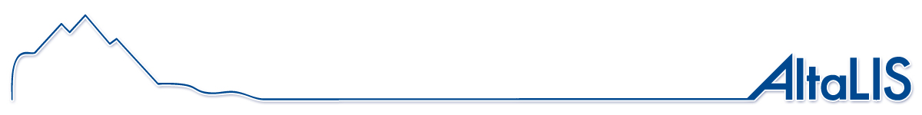
Exploration Restricted Areas

Digital Mapping for Alberta
www.AltaLIS.com

AltaLIS is responsible for the distribution of several digital mapping datasets, including Base Features that are maintained by the Government of Alberta, to the private sector. Base Features is made up of several topographic themes that cover Alberta, and is a seamless GIS spatial database product to which other natural resource and land management information can be related.

The positional accuracy is dependant upon the various sources used for creation. See the 1:20000 Base Feature products for more detail. The information contained within this data set is a mapping representation only and is not an official definition of these boundaries. AltaLIS cannot provide technical support for this free layer, but updates will be posted as they are received.

The following information has been compiled to support this boundary file:

Layer Name: | BF_GEO_ERA_POLYGON
Abstract: Exploration Restricted Areas are areas where no exploration (operations on or over land or water to determine geologic conditions underlying the surface of land or water) including shot hole (a hole drilled for the purpose of detonating an explosive charge for the primary purpose of obtaining geophysical information) or surface energy activity (a power source that is used to generate energy for the purpose of obtaining exploration data) is allowed. These areas are compiled according to Schedule 1, AR 214/98, under authority of the Forests Act, Mines and Minerals Act, Public Highways Development Act, and Public Lands Act.

Purpose: Primarily used for planning, processing and approval of Geophysical applications.

Supplemental Information: As per Section 6 of the Exploration Regulations 214/98, identified areas of Alberta have prohibitions and restrictions on the conduct of geophysical exploration. As restricted areas have increased in number since the inception of the Exploration Regulation, these areas of Alberta are now delineated, described and posted on http://www.srd.gov.ab.ca/land/restr_areas/. Please note that all road allowances, highways, and public roads lying within or adjacent to any of the above described lands are included within the restricted areas. If any discrepancy exists between a description of an area of Alberta and the map or outlining of that area, the description of the area prevails.

Date Created: | 2002 01 15
Date Currency: | 2005 05 05
Last Date Modified: | 2006 03 10
Feature Metadata:

Name Description
ECORES_NAM Name of the feature
ECORES_COD Feature Identifier
GEOMETRY The geometry that defines the location and shape of boundaries

Coordinate system type: Geographic Geodetic Datum: North American 1983
Projection: Cylindrical Equirectangular Reference Ellipsoid: GRS80

Longitude Of Origin: 0:00:00.000 (d:m:s) Horizontal storage unit: 1 deg
Latitude Of Origin: 0:00:00.000 (d:m:s) Vertical storage unit: 1 m
Standard parallel: 0:00:00.000 (d:m:s) Storage center: Longitude: 0.000 deg
Latitude: 0.000 deg
False X: 0.00 m Height: 0.00 m
False Y: 0.00 m GeoNad83

