Catalogue No. 92F0159GIE
Population Ecumene
Census Division Boundary File
2001 Census
Reference Guide
How to obtain more information

Specific inquiries about this product and related statistics or services should be directed to your nearest regional reference centre.

For information on the wide range of data available from Statistics Canada, you can contact us by calling one of our toll-free numbers. You can also contact us by e-mail or by visiting our Web site.

National inquiries line 1 800 263-1136
TTY 1 800 363-7629
E-mail inquiries infostats@statcan.ca
Web site www.statcan.ca

Standards of service to the public

Statistics Canada is committed to serving its clients in a prompt, reliable and courteous manner and in the official language of their choice. To this end, the Agency has developed standards of service which its employees observe in serving its clients. To obtain a copy of these service standards, please contact Statistics Canada toll free at 1 800 263-1136.

Statistics Canada
Population Ecumene
Census Division Boundary File
2001 Census
Reference Guide

Published by authority of the Minister responsible for Statistics Canada

© Minister of Industry, 2002

All rights reserved. No part of this publication may be reproduced, stored in a retrieval system or transmitted in any form or by any means, electronic, mechanical, photocopying, recording or otherwise without prior written permission from Licence Services, Marketing Division, Statistics Canada, Ottawa, Ontario, Canada K1A 0T6.

June 2002

Catalogue no. 92F0159GIE

Ottawa

Note of Appreciation

Canada owes the success of its statistical system to a long-standing partnership between Statistics Canada, the citizens of Canada, its businesses, governments and other institutions. Accurate and timely statistical information could not be produced without their continued cooperation and goodwill.

What’s new?

- The 2001 population ecumene was derived from population at the block level (semi-automatically) for more accurate representation.

- The ecumene product consists of three separate layers:
- 2001 population ecumene with integrated census divisions
- 2001 census divisions
- 2001 provinces / territories

- Large inland lakes (generalized for small-scale mapping) are integrated with the ecumene boundary layer.

- The ecumene boundary layer includes the following data for census divisions:
- 2001 Census population
- 2001 Census population density per square kilometre
- Population change between 1996 and 2001 Censuses

Table of Contents

1. About this guide 1

2. Overview 2
The Population Ecumene Census Division Boundary File
Reference Date

3. How to use the product 4
Purpose of the product
Limitations
General Methodology
Content
Comparison to the 1996 Population Ecumene

4. Data quality 9
Lineage
Positional accuracy
Attribute accuracy
Logical consistency
Completeness

5. Technical specifications 13
Software formats
Installation instructions
File naming conventions
File names and sizes
Data descriptions and record layouts

6. Glossary 18

Appendix A: Hierarchy of standard geographic units for dissemination, 2001 Census 24

Appendix B: Geographic units by province and territory, 2001 Census 25

Appendix C: Unique identifiers consistent with other Geography products 26

Appendix D: Spatial file naming conventions 27

References 30

Geography products and services 32

End-Use Licence Agreement 38

1. About this guide

This reference guide briefly discusses the 2001 Population Ecumene Census Division Boundary File, including the general methodology used to create the product. Information on data quality is contained in Section 4.

Technical specifications in Section 5 include system requirements, installation guidelines, record layout, and file naming conventions for the ARC/INFO® and the MapInfo® for Windows® versions.

Geographic terms and concepts highlighted in bold in the text are described in the glossary. More details can be found in the 2001 Census Dictionary, Catalogue No. 92-378-XIE. Supplementary information is provided in the appendices and a list of related products and services is also included.

This reference guide does not provide details on specific software packages available for use with the 2001 Population Ecumene Census Division Boundary File. Users are advised to contact the appropriate software vendor for information. Please contact your nearest Regional Reference Centre for further information.

This reference guide is based on the best information available at the time of its release. It in no way constitutes a warranty of the data in the event that users may observe characteristics that deviate from those stated in this document. All efforts have been made to ensure a thorough verification of this product, however, there is no guarantee that the data are 100% accurate. For further information see Section 4, Data quality.

2. Overview

The Population Ecumene Census Division Boundary File

Ecumene is a term used by geographers to mean inhabited land. It generally refers to land where people have made their permanent home, and to all work areas that are considered occupied and used for agricultural or any other economic purposes. Thus, there can be various types of ecumenes, each having their own unique characteristics (population ecumene, agricultural ecumene, industrial ecumene, etc.). Ecumene is derived from the Greek root oixos meaning inhabited and nenon meaning space.

The population ecumene is based on blocks with a minimum population density of 0.4 persons per square kilometre (about one person per square mile). To ensure visibility for small-scale thematic mapping, the detailed ecumene limits are generalized and small, discontiguous ecumene pockets are aggregated. There is at least one ecumene pocket (polygon) in every census division.

The Population Ecumene Census Division Boundary File consists of three separate layers of information. The first layer contains the population ecumene with polygons for every census division. The second layer contains census divisions boundaries. The third layer contains provincial / territorial boundaries. The second and third layers are used to map the population ecumene with either of these boundaries.

Figure 1 shows the change in population with population ecumene, province / territory and census division boundaries.
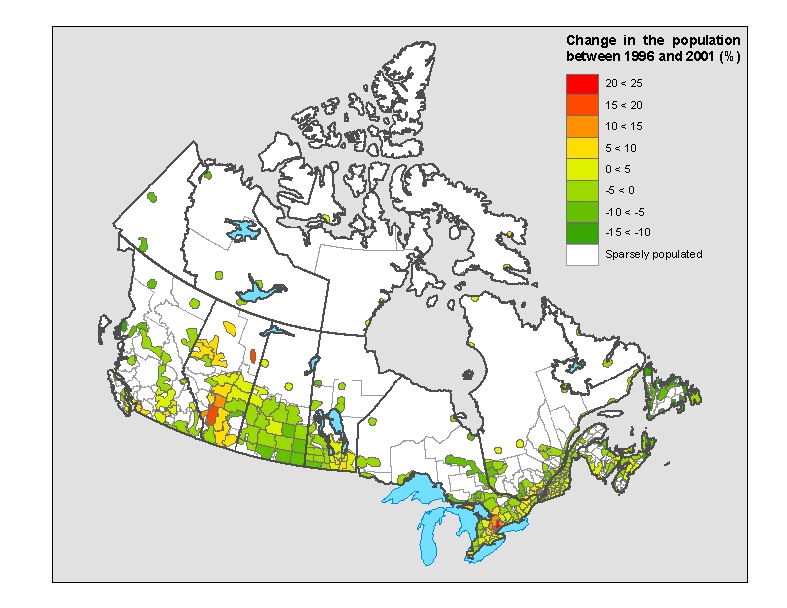
The ecumene boundary layer contains the following attributes: 2001 Census population, population change between 1996 and 2001, 2001 Census population density per square kilometre and 1996 Census population. Large inland lakes and shoreline are incorporated. A flag is used to distinguish between land and water polygons. Geographic co-ordinates are in latitude / longitude and are based on the North American Datum of 1983 (NAD83).

The Population Ecumene Census Division Boundary File is available in ARC/INFO® interchange format or MapInfo® interchange format. The file may be downloaded free of charge from the Statistics Canada web site (www.statcan.ca). Please see the Technical specifications (section 5) for more details on record layouts and file formats.

Reference Date

The geographic reference date is a date determined by Statistics Canada for the purpose of finalizing the geographic framework for which census data will be collected, tabulated and reported. For the 2001 Census, the geographic reference date is January 1, 2001. This is the reference date for the provincial / territorial boundaries, the census division boundaries and the 2001 population data in the Population Ecumene Census Division Boundary File.

3. How to use the product

Purpose of the product

The population ecumene is disseminated to enable users to thematically map census division data. It enables users to display data where population is concentrated (where there are ecumene pockets) in Canada. Thus, data that describes population characteristics can be assigned to and displayed within the ecumene.

Figure 2: The ecumene layer showing population density with province / territory and census division boundaries.

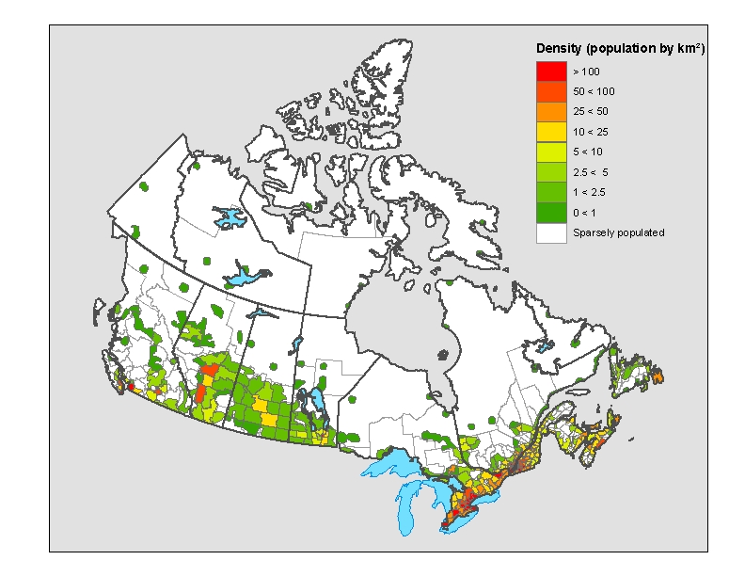

The ecumene concept is recommended for use in dot and choropleth maps. If an ecumene is not applied to dot maps, the requisite number of dots may be randomly spread over entire unit areas; this approach defeats the main attributes of dot mapping (i.e. showing correct location, extent and density of the dot symbols). One of the inherent limitations of choropleth maps is that the statistical distribution is assumed to be homogeneous or uniformly spread over each unit area, and is consequently represented by tones or colours covering the entire unit. Thus, an ecumene renders a more accurate depiction of the spatial distribution of data.

This product was created for the display of thematic data on national maps. Although the product was designed to display census division data, data may be displayed without census division boundaries as a flag is used to distinguish ecumene and non-ecumene polygons in the boundary layer.

Limitations

The ecumene file and surrounding shoreline has been generalized to be suitable for cartographic display at a small scale (1:20,000,000 to 1:25,000,000). The position of the boundaries and shorelines are not compatible with the 2001 Census Cartographic Boundary Files, Road Network Files and Skeletal Road Network Files.

General Methodology

The 2001 ecumene was created using spatial data from the National Geographic Base. The National Geographic Base contains the boundaries of 2001 Census blocks. Population data from the 2001 Census are available at the block level. The detailed block level data were used to derive the population ecumene.

Census block polygons with a population density of 0.4 people or greater per square kilometre were selected and aggregated to create a base layer. This base layer contained several polygons that met the density criteria. Various steps were taken to generalize this base layer to create a product suitable for small scale mapping of census division data. These steps included aggregation of neighbouring polygons as well as generalisation of the outline of the ecumene. Very small polygons were removed as part of the generalization process.

The 2001 census division boundaries were incorporated into the ecumene. The ecumene was verified to ensure that an ecumene pocket existed for every census division. A generalized shoreline including the Great Lakes and large interior lakes was also integrated into the final layer. Discrepancies were cleaned in a manual process to finalize the product.

The census division boundary layer and the province / territory boundary layer were derived from the National Geographic Base and were integrated with the hydrography used for the population ecumene. The census division boundary layer was assigned census division names from the Query Base, a database maintained within Statistics Canada. The province / territory boundary layer was also assigned province / territory names from the Query Base.

Content

This product contains three separate layers of information: the ecumene boundary layer, the census division boundary layer and the province / territory boundary layer.

The ecumene boundary layer consists of a polygon layer. Polygons in the layer are classified as being part of the landmass or as water. Land polygons contain attributes classifying them as part of the ecumene or as part of the sparsely populated areas not assigned to the ecumene. Every census division contains at least one ecumene polygon. Each polygon has the census division unique identifier code (CDuid), as an attribute along with data such as the 2001 Census population, population density per square kilometre and the percentage change in population between the 1996 and 2001 Censuses.

Figure 3: The ecumene boundary layer
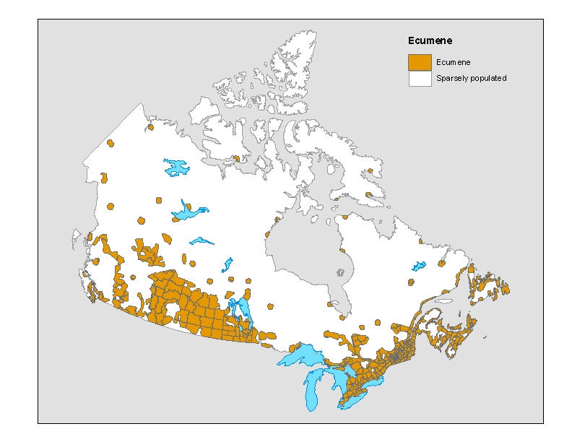
The census division boundary layer consists of polygons classified as being part of the landmass or as water. Polygons representing every census division are included in this file. Each census division polygon contains its unique identification code (the CDuid) and name as an attribute. This layer is provided solely for mapping the boundaries of the Census Division in a map of the population ecumene.

Figure 4: The census division boundary layer

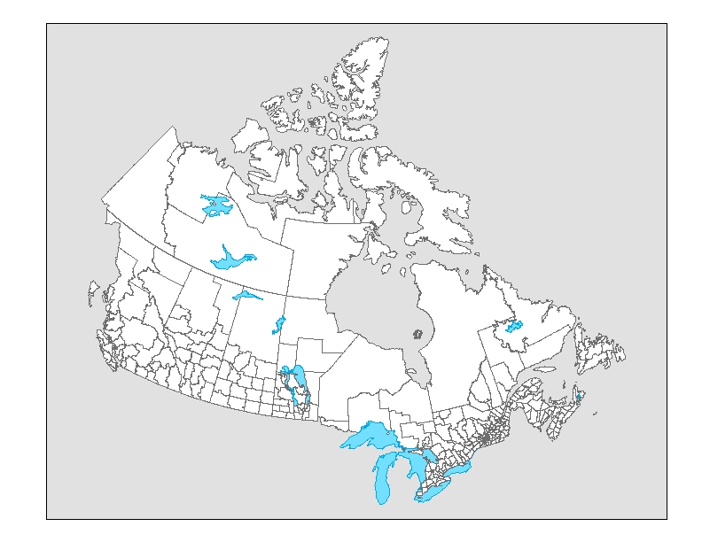

The province / territory boundary layer consists of polygons classified as being part of the landmass or as water. Polygons representing every province / territory are included in this file. Each province / territory polygon contains its unique identification code (the PRuid) and name as an attribute. This boundary layer is provided solely for mapping the boundaries of the provinces and territories in a map of the population ecumene.

Figure 5: The province / territory boundary layer

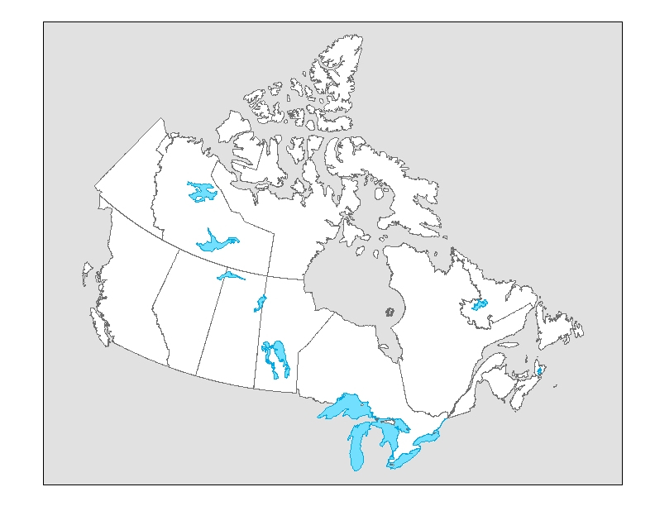
Comparison to the 1996 Population Ecumene

The 2001 Census population ecumene differs slightly from those available for the 1991 and 1996 Censuses. For the 2001 Census, the population ecumene was generalized based on population data for blocks. In 1991 and 1996, the population ecumene was derived from less detailed enumeration area data.

The 2001 Census product includes two layers of boundaries and more attributes than the 1996 product.

Previous to 2001, ecumene files were created using a largely manual process. Recent developments in software and hardware have made it possible to semi-automate the process.

4. Data quality

Spatial data quality elements provide information on the fitness-for-use of a spatial database by describing why, when and how the data are created, and how accurate the data are. The elements include an overview describing the purpose and usage, as well as specific quality elements reporting on the lineage, positional accuracy, attribute accuracy, logical consistency and completeness. This information is provided to users for all spatial data products disseminated for the census.

Lineage

Describes the history of the spatial data, including descriptions of the source material from which the data were derived, and the methods of derivation. It also contains the dates of the source material, and all transformations involved in producing the final digital files or map products.

The base ecumene layer was created by selecting blocks having a population density of 0.4 persons per square kilometre, or greater. Every block polygon was classified as either being an ecumene block (meeting the population density criteria) or not being an ecumene block.

The base ecumene layer was divided into three layers: main ecumene, ecumene pockets (outside the main ecumene) and non-ecumene pockets (within the main ecumene). Different generalization criteria were applied to each of the layers in order to create a product for small-scale mapping. The final criteria were determined after extensive testing and mapping.

The ecumene pockets were enlarged with a buffer of five kilometres (that is, the area was extended by five kilometres all around each pocket). Then, an aggregation procedure was applied so that neighbouring pockets could be grouped together to create larger and more visible ecumene pockets. The aggregation application converted the file from vector into grid format according to specified cell size and aggregated together polygons based on a given distance between the polygons. In all cases, this distance had to be greater than the cell size. The ecumene pockets were assigned a greater cell size of 4000m² and a distance of 4001m. The resulting grid was then converted back into a vector file. Very small ecumene pockets were removed after the aggregation procedure.

Similar criteria were used to aggregate the non-ecumene pockets. They were also initially enlarged with a five kilometre buffer. Then they were assigned a cell size of 2000m² and aggregated at a distance of up to 2001m. Small non-ecumene pockets within the ecumene were removed.

The three layers were then reintegrated. A visual check was done to ensure that there was at least one polygon for each census division. Where there were numerous small polygons, extra small polygons were eliminated on a case by case basis.

As with the previous step, three files were created in order to apply separate generalization criteria on the main ecumene, ecumene pockets (outside the main ecumene) and non-ecumene pockets (inside the main ecumene). A buffer of 10 kilometres was added to increase size for better cartographic display. The three files were generalized using a line smoothing technique. The main ecumene layer was further generalized. The pockets were less generalized (relative to the main ecumene) to better preserve the shape of these smaller polygons. The three converages were then integrated to produce a generalized layer.

The 2001 census division boundary files derived from the National Geographic Base were intersected with the resulting generalized ecumene, keeping the census division unique identifier as the basic attribute. The generalized ecumene was then clipped with the generalized hydrographic layer and polygons outside of ecumene were coded as LAND and WATER respectively. The final processing, the most manual, involved cleaning up slivers (small thin polygons) created by the integration of generalized hydrography with more detailed census division boundaries.

The census division boundary layer was created by intersecting a census division boundary file derived independently from the National Geographic Base with the population ecumene’s generalized hydrography. The resulting layer was cleaned of slivers and was then linked with attribute data from the Query Base.

The province / territory boundary layer was derived from the generalized census division layer by aggregating shared province / territory identifiers. This spatial file was then linked to the attribute data from the Query Base.

Positional accuracy

Refers to the absolute and relative accuracy of the positions of geographic features. Absolute accuracy is the closeness of the coordinate values in a dataset to values accepted as or being true. Relative accuracy is the closeness of the relative positions of features to their respective relative positions accepted as or being true. Descriptions of positional accuracy include the quality of the final file or product after all transformations.

While the boundaries were originally derived from the National Geographic Base, they have been greatly generalized (particularly on the shorelines and the boundary of Canada) and are not positionally consistent with data on the base.

Attribute accuracy

Refers to the accuracy of the quantitative and qualitative information attached to each feature (such as population for an urban area, street name, census subdivision name and code).

The CDuid assigned to each polygon in the census division layer was verified against a census division layer independently derived from the National Geographic Base. The CDuid in the ecumene boundary layer was also verified in this way.

The PRuid was verified against a province / territory layer independently derived from the National Geographic Base.

The following attributes in the ecumene boundary layer were verified against GeoSuite: CDuid, PRuid, CDpop2001 and CDpop1996.

The following attributes in the census division boundary layer were verified against GeoSuite: CDuid, CDname, and CDtype.

The following attributes in the province / territory boundary layer were verified against GeoSuite: PRuid, PRename, PRfname, PReabbr, PRfabbr.

Logical consistency

Describes the fidelity of relationships encoded in the data structure of the digital spatial data.

Conceptual consistency
The adherence to rules of the conceptual schema.

Every ecumene polygon in the ecumene boundary layer was verified to contain a unique identifier for each census division: the CDuid.

Every polygon in the province / territory boundary layer was verified to contain a unique identifier for each province / territory: the PRuid.

Every polygon in the census division boundary layer was verified to contain a unique identifier for each census division: the CDuid.

Domain consistency
The adherence of values to the value domains.

Every CDuid and PRuid in the appropriate layers were verified to be in the Query Base as a valid value for the 2001 Census.

Topological consistency
Correctness of the explicitly encoded topological characteristics of a dataset.

This product was checked to ensure that the polygons were consistent with the geographic units being represented. Very small polygons and slivers (resulting from the integration of different layers of information) were removed.

The ecumene boundary layer was verified to contain an ecumene pocket for every census division.

Consistency with other products
The boundaries in the various layers in this file are more generalized. They are not positionally consistent with the Cartographic Boundary File or any other boundary files. The boundaries are also not consistent with the Road Network Files or Skeletal Road Network Files.

As the hydrography is different from those of other products, land area on these files is not consistent with land area found in the Cartographic Boundary Files or in GeoSuite.

The PRuid and CDuid in this product are consistent with those in GeoSuite.

The names of the provinces / territories and census divisions as well as the 2001 Census population data are consistent with those in GeoSuite.

Completeness

Refers to the degree to which geographic features, their attributes and their relationships are included or omitted in a dataset. It also includes information on selection criteria, definitions used, and other relevant mapping rules.

In the ecumene boundary layer, at least one ecumene pocket exists for every census division. Each ecumene pocket contains a census division unique identifier (CDuid) as well as the following population related attributes:
- 2001 Census population
- 2001 Census population density per square kilometre
- Population change between 1996 and 2001 Censuses

The census division boundary file contains polygons for every census division.

The province / territory boundary file contains polygons for every province / territory.

The unique identifiers (CDuid and PRuid) as well as the 2001 Census population data were verified against the Query Base.

5. Technical specifications

Software formats

All products are available on CD-ROM in the following formats:
- ARC/INFO® interchange format version 8.1
ASCII interchange file
File extension: .e00 (spatial and tabular data)
- MapInfo® interchange format version 6.0
ASCII interchange files
File extensions: .MIF (graphic data), .MID (tabular data)

Installation instructions

Both the ARC/INFO® and the MapInfo® files are compressed into self-executable WinZip® files (file extension .EXE). Users can unzip these files by executing them in DOS, or selecting them in Windows® and double clicking on the file icon, or executing them in the RUN dialog in Windows®.

File naming conventions

The conventions used are:
ARC/INFO® gecp000e02a_e.e00
gecd000e02a_e.e00
gepr000e02a_e.e00

MapInfo® gecp000e02m_e.mif and gecp000e02m_e.mid
gecd000e02m_e.mif and gecd000e02m_e.mid
gepr000e02m_e.mif and gepr000e02m_e.mid

Where g refers to geographic representation, ecp indicates that the file is population ecumene, 000 is the three digit code identifying it is a national file, E indicates it is an ecumene (the agricultural ecumene is included in this category). 02 is the date stamp for year of release, m or a indicates software and e or f indicates language of file. For more information on the file naming conventions, please consult Appendix D.

File names and sizes

File names are formatted in order to better indicate to the client the source of data, coverage, geographic area, language and file format of the data.

File | ARC/INFO® |  |  | MapInfo®
File | File name | File size (MB) | File name |  | File size (MB)
Population ecumene boundary file | gecp000e02a_e | 1.7 | gecp000e02m_e |  | 2.8
Census division boundary file | gecd000e02a_e | 5.0 | gecd000e02m_e |  | 5.5
Province / territory boundary file | gepr000e02a_e | 1.2 | gepr000e02m_e |  | 1.1

Data descriptions and record layouts

All spatial products are available in the following geographic representation:
- Datum NAD83
- Projection Geographic
- Co-ordinates Latitude / Longitude

Population ecumene layer record layout:

The following table shows the format of the attributes contained on the ecumene boundary file with integrated hydrographic features.

Item | Width | Output | Type | Decimals
AREA¹ | 4 | 12 | F | 3
PERIMETER¹ | 4 | 12 | F | 3
Username# ¹ | 4 | 5 | B | 0
Username-ID ¹ | 4 | 5 | B | 0
Cduid | 4 | 4 | C | -
CDpop2001 | 4 | 11 | F | 0
CDpop_96_01 | 4 | 18 | F | 1
CDdens2001 ² | 4 | 18 | F | 1
CDpop1996 | 4 | 11 | F | 0
PRuid | 2 | 2 | C | -
ECUMENE ² | 1 | 1 | I | -
LAND_WATER ² | 1 | 1 | I | -
¹ Items included with ARC/INFO® interchange files only
² New for 2001 Ecumene

Item | Description
AREA | area of the polygon - maintained by ARC/INFO® (item not included in MapInfo® files)
PERIMETER | perimeter of the polygon - maintained by ARC/INFO® (item not included in MapInfo® files)
Username# | maintained by ARC/INFO® for internal processing (item not included in MapInfo® files)
Username-ID | maintained by ARC/INFO® for internal processing (item not included in MapInfo® files)
Cduid | uniquely identifies a census division (Standard Geographical Classification code - composed of the 2-digit province code and the 2-digit census division code)
CDpop2001 | 2001 census division population
CDpop_96_01 | population change from 1996 to 2001, using 2001 boundaries
CDdens2001 | population density by census division for 2001
CDpop1996 | 1996 population adjusted to 2001 census divisions
PRuid | uniquely identifies a province or territory
ECUMENE | value of “1” for ecumene and “0” for out of ecumene (sparsely populated)
LAND_WATER | value of “1” for land and “2” for water

Census division layer record layout:

The following polygon attribute table shows the format of the attributes contained on the boundary files with integrated hydrographic features.

Item | Width | Output | Type | Decimals
AREA¹ | 8 | 18 | F | 5
PERIMETER¹ | 8 | 18 | F | 5
<File name># ¹ | 4 | 5 | B | 0
<File name>-ID ¹ | 4 | 5 | B | 0
CDname | 50 | 50 | C | -
CDuid | 4 | 4 | C | -
CDtype ² | 3 | 3 | C | -
PRuid | 2 | 2 | C | -
WATER | 1 | 1 | I | -
¹ Items included with ARC/INFO® interchange files only
² New for 2001 Ecumene

Item | Description
AREA | area of the polygon - maintained by ARC/INFO® (item not included in MapInfo® files)
PERIMETER | perimeter of the polygon - maintained by ARC/INFO® (item not included in MapInfo® files)
<File name># | maintained by ARC/INFO® for internal processing (item not included in MapInfo® files)
<File name>-ID | maintained by ARC/INFO® for internal processing (item not included in MapInfo® files)
CDname | the official census division name
CDuid | uniquely identifies a census division (Standard Geographical Classification code - composed of the 2-digit province code and the 2-digit census division code)
CDtype | the type of the census division (see table below)
PRuid | uniquely identifies a province or territory
WATER | value of “1” for water and “0” for land

Census division types:

Abbreviation | Census division type
CTY | County
CU | Communauté urbaine
DIS | District
DIV | Census Division
DM | District Municipality
MRC | Municipalité régionale de comté (MRC)
RD | Regional District
REG | Region
RM | Regional Municipality
TER | Territory
UC | United Counties

Province / territory layer record layout:

The following polygon attribute table shows the format of the attributes contained on the boundary files with integrated hydrographic features.

Item | Width | Output | Type | Decimals
AREA¹ | 8 | 18 | F | 5
PERIMETER¹ | 8 | 18 | F | 5
<File name># ¹ | 4 | 5 | B | 0
<File name>-ID ¹ | 4 | 5 | B | 0
PRename | 25 | 25 | C | -
PRfname | 25 | 25 | C | -
PRuid | 2 | 2 | C | -
PReabbr | 10 | 10 | C | -
PRfabbr | 10 | 10 | C | -
WATER | 1 | 1 | I | -
¹ Items included with ARC/INFO® interchange files only

Item | Description
AREA | area of the polygon - maintained by ARC/INFO® (item not included in MapInfo® files)
PERIMETER | perimeter of the polygon - maintained by ARC/INFO® (item not included in MapInfo® files)
<File name># | maintained by ARC/INFO® for internal processing (item not included in MapInfo® files)
<File name>-ID | maintained by ARC/INFO® for internal processing (item not included in MapInfo® files)
PRename | the province or territory name in English
PRfname | the province or territory name in French
PRuid | uniquely identifies a province or territory
PReabbr | the official English abbreviation for the province name
PRfabbr | the official French abbreviation for the province name
WATER | value of “1” for water and “0” for land

6. Glossary

Adjusted Counts
Adjusted counts refer to previous census population and dwelling counts that have been adjusted (i.e., recompiled) to reflect current census boundaries (such as when a boundary change occurs between two censuses).

Block
A block is an area bounded on all sides by roads and/or boundaries of standard geographic areas. Blocks cover all the territory of Canada. The block is the smallest geographic area for which population and dwelling counts are disseminated.

Block-face
A block-face is one side of a street between two consecutive features intersecting that street. The features can be other streets, boundaries of standard geographic areas, or limits of map tiles.

Block-faces are used for generating block-face representative points, which in turn are used for geocoding and census data extraction when the street and address information is available.

Cartographic Boundary Files
Cartographic Boundary Files (CBF) contain boundaries of standard geographic areas, along with shorelines and lakes, at a level of detail appropriate for small-scale mapping.

Census Agricultural Region
Census agricultural regions (CAR) are composed of groups of adjacent census divisions. In Saskatchewan, census agricultural regions are made up of groups of adjacent census consolidated subdivisions, but these groups do not necessarily respect census division boundaries.

Census Consolidated Subdivision
A census consolidated subdivision (CCS) is a grouping of adjacent census subdivisions. Generally, the smaller, more urban census subdivisions (towns, villages, etc.) are combined with the surrounding larger, more rural census subdivision, in order to create a geographic level between the census subdivision and the census division.

Census Division
Census division (CD) is the general term for provincially legislated areas (such as county, municipalité régionale de comté and regional district) or their equivalents. Census divisions are intermediate geographic areas between the province level and the municipality (census subdivision).

Census Metropolitan Area and Census Agglomeration
A census metropolitan area (CMA) or a census agglomeration (CA) is formed by one or more adjacent municipalities centred on a large urban area (known as the urban core). The census population count of the urban core must be at least 10,000 to form a census agglomeration and at least 100,000 to form a census metropolitan area. To be included in the CMA or CA, other adjacent municipalities must have a high degree of integration with the central urban area, as measured by commuting flows derived from census place of work data.

If the population of the urban core of a CA declines below 10,000, the CA is retired. However, once an area becomes a CMA, it is retained as a CMA even if the population of its urban core population declines below 100,000. The urban areas that are located in the CMA or CA but are not contiguous to the urban core are called the urban fringe. Rural areas in the CMA or CA are called the rural fringe.

When a CA has an urban core of at least 50,000 based on census counts, it is subdivided into census tracts. Census tracts are maintained for the CA even if the population of the urban core subsequently falls below 50,000. All CMAs are subdivided into census tracts.

Census Metropolitan Area and Census Agglomeration Influenced Zone
The census metropolitan area and census agglomeration influenced zone (MIZ) is a concept that geographically differentiates the area of Canada outside census metropolitan areas (CMAs) and census agglomerations (CAs). Census subdivisions outside CMAs and CAs are assigned to one of four categories according to the degree of influence (strong, moderate, weak or no influence) that the CMAs and/or CAs have on them.

Census subdivisions (CSDs) are assigned to a MIZ category based on the percentage of their resident employed labour force that has a place of work in the urban core(s) of CMAs or CAs. CSDs with the same degree of influence tend to be clustered. The zones they form around CMAs and CAs progress through the categories from “strong” to “no” influence as distance from the CMAs and CAs increases.

Census Subdivision
Census subdivision (CSD) is the general term for municipalities (as determined by provincial legislation) or areas deemed to be their equivalents (for example, Indian reserves, Indian settlements and unorganized territories) used for statistical reporting purposes.

Census Tract
Census tracts (CTs) are small, relatively stable geographic areas that usually have a population of 2,500 to 8,000. They are located in census metropolitan areas (CMAs) and in census agglomerations (CAs) with an urban core population of 50,000 or more in the previous census.

A committee of local specialists (for example, planners, educators and health and social workers ) initially delineates CTs in conjunction with Statistics Canada. Once a CMA or CA has been subdivided into census tracts, the census tracts are maintained even if the urban core population subsequently declines below 50,000.

Co-ordinate System
A co-ordinate system is a reference system based on mathematical rules for specifying positions (locations) on the surface of the earth. The co-ordinate values can be spherical (latitude and longitude) or planar (such as the Universal Transverse Mercator).

The Cartographic Boundary Files, the Road Network Files and the representative points are disseminated in latitude / longitude co-ordinates.

Datum
A datum is a geodetic reference system that specifies the size and shape of the earth, and the base point from which the latitude and longitude of all other points on the earth’s surface are referenced.

The spatial data disseminated for the 2001 Census are based on the North American Datum of 1983 (NAD83).
Designated Place
A designated place (DPL) is normally a small community or settlement that does not meet the criteria established by Statistics Canada to be a census subdivision (an area with municipal status) or an urban area.

Designated places are created by provinces and territories, in co-operation with Statistics Canada, to provide data for submunicipal areas.

Dissemination Area
The dissemination area (DA) is a small, relatively stable geographic unit composed of one or more blocks. It is the smallest standard geographic area for which all census data are disseminated. DAs cover all the territory of Canada.

Economic Region
An economic region (ER) is a grouping of complete census divisions (with one exception in Ontario) created as a standard geographic unit for analysis of regional economic activity.

Ecumene
Ecumene is a term used by geographers to mean inhabited land. It generally refers to land where people have made their permanent home, and to all work areas that are considered occupied and used for agricultural or any other economic purposes. Thus, there can be various types of ecumenes, each having its own unique characteristics (population ecumene, agricultural ecumene, industrial ecumene, etc.).

Enumeration Area
An enumeration area (EA) is the geographic area canvassed by one census representative. An EA is composed of one or more adjacent blocks. EAs cover all the territory of Canada.

Enumeration areas are only used for census data collection. The dissemination area (DA) replaces the EA as a basic unit for dissemination.

Federal Electoral District
A federal electoral district (FED) is an area represented by a member of the House of Commons. The federal electoral district boundaries used for the 2001 Census are based on the 1996 Representation Order.

Geocoding
Geocoding is the process of assigning geographic identifiers (codes) to map features and data records. The resulting geocodes permit data to be linked geographically.

Households and postal codes are linked to block-face representative points when the street and address information is available; otherwise, they are linked to block representative points.

Geographic Code
A geographic code is a unique number used to identify and access standard geographic areas for the purposes of data storage, retrieval and display.

Geographic Reference Date
The geographic reference date is a date determined by Statistics Canada for the purpose of finalizing the geographic framework for which census data will be collected, tabulated and reported. For the 2001 Census, the geographic reference date is January 1, 2001.
Land Area
Land area is the area in square kilometres of the land-based portions of standard geographic areas.

The land area measurements are unofficial and are provided for the sole purpose of calculating population density.

Locality
Locality (LOC) refers to the historical place names of former census subdivisions (municipalities), former designated places and former urban areas, as well as to the names of other entities, such as neighbourhoods, post offices, communities and unincorporated places.

Map Projection
A map projection is the process of transforming and representing positions from the earth’s three-dimensional curved surface to a two-dimensional (flat) surface. The process is accomplished by a direct geometric projection or by a mathematically derived transformation.

The Lambert Conformal Conic map projection is widely used for general maps of Canada at small scales and is the most common map projection used at Statistics Canada.

National Geographic Base
The National Geographic Base (NGB) is a new database that contains roads and boundaries of standard geographic areas in one integrated layer with other physical and cultural features (such as hydrography, railroads and power transmission lines) stored as separate layers.

The NGB is an internal maintenance database that is not disseminated. It supports a wide range of census operations, such as geocoding, updating the road network and address ranges, supporting the block program and delineating the boundaries of standard geographic areas (including the automated delineation of enumeration areas, urban areas and dissemination areas). As well, the NGB is the source for generating many geography products for the 2001 Census, such as reference maps and Cartographic Boundary Files.

Place Name
Place name (PN) refers to the set of names that includes current census subdivisions (municipalities), current designated places and current urban areas, as well as the names of localities.

Population Density
Population density is the number of persons per square kilometre.

Postal Code
The postal code is a six-character code defined and maintained by Canada Post Corporation for the purpose of sorting and delivering mail.

Province or Territory
Province and territory refer to the major political units of Canada. From a statistical point of view, province and territory are basic areas for which data are tabulated. Canada is divided into ten provinces and three territories.

Reference Map
A reference map shows the location of the geographic areas for which census data are tabulated and disseminated. The maps display the boundaries, names and codes of standard geographic areas, as well as major cultural and physical features, such as roads, railroads, coastlines, rivers and lakes.

Representative Point
A representative point is a single point that represents a linear or areal feature. The point is centrally located along the linear feature or centrally within the areal feature.

Representative points are generated for block-faces, blocks, enumeration areas, dissemination areas, census subdivisions and designated places. The block-face and block representative points support the geocoding of households and postal codes.

Road Network Files
The Road Network Files (RNFs) provide national coverage of roads, province / territory boundaries and other visible features such as hydrography, as well as attribute information (for example, street names and address ranges for streets with assigned addresses). The RNFs replace the Street Network Files (SNFs), which were a similar product previously available only for the large urban centres of Canada.

Rural Area
Rural areas include all territory lying outside urban areas. Taken together, urban and rural areas cover all of Canada.

Rural population includes all population living in the rural fringes of census metropolitan areas (CMAs) and census agglomerations (CAs), as well as population living in rural areas outside CMAs and CAs.

Spatial Data Quality Elements
Spatial data quality elements provide information on the fitness-for-use of a spatial database by describing why, when and how the data are created, and how accurate the data are. The elements include an overview describing the purpose and usage, as well as specific quality elements reporting on the lineage, positional accuracy, attribute accuracy, logical consistency and completeness. This information is provided to users for all spatial data products disseminated for the census.

Standard Geographical Classification
The Standard Geographical Classification (SGC) is Statistics Canada’s official classification for three types of geographic areas: provinces and territories, census divisions (CDs) and census subdivisions (CSDs). The SGC provides unique numeric identification (codes) for these hierarchically related geographic areas.

Statistical Area Classification
The Statistical Area Classification (SAC) groups census subdivisions according to whether they are a component of a census metropolitan area, a census agglomeration, a census metropolitan area and census agglomeration influenced zone (strong MIZ, moderate MIZ, weak MIZ or no MIZ), or the territories (Northwest Territories, Yukon Territory and Nunavut). The SAC is used for data dissemination purposes.

Thematic Map
A thematic map shows the spatial distribution of one or more specific data themes for standard geographic areas. The map may be qualitative in nature (e.g., predominant farm types) or quantitative (e.g., percentage population change).
Urban Area
An urban area (UA) has a minimum population concentration of 1,000 persons and a population density of at least 400 persons per square kilometre, based on the current census population count. All territory outside urban areas is classified as rural. Taken together, urban and rural areas cover all of Canada.

Urban population includes all population living in the urban cores, secondary urban cores and urban fringes of census metropolitan areas (CMAs) and census agglomerations (CAs), as well as the population living in urban areas outside CMAs and CAs.

Urban Core, Urban Fringe and Rural Fringe
Urban core, urban fringe and rural fringe distinguish between central and peripheral urban and rural areas within a census metropolitan area (CMA) or census agglomeration (CA).

Urban core is a large urban area around which a CMA or a CA is delineated. The urban core must have a population (based on the previous census) of at least 100,000 persons in the case of a CMA, or between 10,000 and 99,999 persons in the case of a CA.

Urban fringe includes all small urban areas (with less than 10,000 population) that are located within a CMA or CA but are not contiguous with the urban core of the CMA or CA.

Rural fringe comprises all territory that is located within a CMA or CA but is not classified as an urban core or an urban fringe.

Urban Population Size Group
Urban population size group refers to the classification used in standard tabulations where urban areas are distributed according to the following predetermined size groups, based on the current census population.

1,000 – 2,499
2,500 – 4,999
5,000 – 9,999
10,000 – 24,999
25,000 – 49,999
50,000 – 99,999
100,000 – 249,999
250,000 – 499,999
500,000 – 999,999
1,000,000 and over

Tabulations are not limited to these predetermined population size groups; the census database has the capability of tabulating data according to any user-defined population size group.

Appendix A: Hierarchy of standard geographic units for dissemination, 2001 Census
Appendix B: Geographic units by province and territory, 2001 Census
Geographic Unit | Canada |  | Nfld. Lab. | P.E.I. | N.S. | N.B. | Que. | Ont. | Man. | Sask. | Alta. | B.C. | Y.T. | N.W.T. | Nvt.
Geographic Unit | 1996 | 2001
Federal electoral district (1996 Representation Order) | 295* | 301 | 7 | 4 | 11 | 10 | 75 | 103 | 14 | 14 | 26 | 34 | 1 | 1 | 1
Economic region | 74 | 76 | 4 | 1 | 5 | 5 | 17 | 11 | 8 | 6 | 8 | 8 | 1 | 1 | 1
Census agricultural region | 78 | 82 | 3 | 3 | 5 | 4 | 14 | 5 | 12 | 20 | 8 | 8 | – | – | –
Census division | 288 | 288 | 10 | 3 | 18 | 15 | 99 | 49 | 23 | 18 | 19 | 28 | 1 | 2 | 3
Census consolidated subdivision | 2,607 | 2,446 | 87 | 68 | 43 | 151 | 1,111 | 318 | 127 | 301 | 77 | 157 | 1 | 2 | 3
Census subdivision | – | 5,600 | 381 | 113 | 98 | 275 | 1,476 | 586 | 298 | 1,002 | 452 | 816 | 35 | 37 | 31
1996 Census | 5,984 | – | 381 | 113 | 110 | 283 | 1,599 | 947 | 298 | 970 | 467 | 713 | 35 | 68 | N/A
Dissolutions (January 2, 1996 to January 1, 2001) | 910 | – | – | – | 14 | 12 | 232 | 529 | 3 | 18 | 18 | 83 | 1 | – | N/A
Incorporations (January 2, 1996 to January 1, 2001) | – | 526 | – | – | 2 | 4 | 109 | 168 | 3 | 50 | 3 | 186 | 1 | – | N/A
Designated place | 828 | 1,261 | 182 | – | 59 | 172 | 78 | 81 | 51 | 158 | 260 | 219 | 1 | – | –
Census metropolitan area | 25 | 27 | 1 | – | 1 | 1 | 6 | 11 | 1 | 2 | 2 | 3 | – | – | –
Census agglomeration  With census tracts  Without census tracts | 112  18  94 | 113  19  94 | 4  –  4 | 2  –  2 | 4  –  4 | 5  1  4 | 28  3  25 | 30  8  22 | 3  –  3 | 7  –  7 | 10  3  7 | 22  4  18 | 1  –  1 | 1  –  1 | –  –  –
Census tract | 4,223 | 4,798 | 45 | – | 86 | 71 | 1,263 | 2,013 | 165 | 101 | 457 | 597 | – | – | –
Urban area | 929 | 913 | 36 | 7 | 39 | 34 | 229 | 258 | 42 | 65 | 108 | 93 | 1 | 3 | 3
Locality | N/A | 52,291 | 2,428 | 964 | 3,920 | 3,445 | 12,448 | 10,889 | 2,339 | 3,868 | 3,466 | 7,699 | 362 | 173 | 290
Dissemination area | N/A | 52,993 | 1,231 | 225 | 1,397 | 1,349 | 12,153 | 18,596 | 2,235 | 2,937 | 5,143 | 7,463 | 117 | 92 | 55
Enumeration area | 49,361 | 42,851 | 1,204 | 225 | 1,337 | 1,216 | 9,133 | 14,753 | 1,805 | 2,697 | 4,129 | 6,088 | 117 | 92 | 55
Block | N/A | 478,707 | 8,331 | 2,831 | 15,161 | 13,929 | 108,760 | 128,327 | 30,567 | 56,040 | 60,061 | 53,147 | 674 | 745 | 134
Block-face | 817,734 | 3,764,232 | 80,162 | 19,854 | 168,840 | 136,311 | 865,600 | 955,847 | 200,569 | 377,776 | 435,604 | 499,365 | 10,644 | 12,304 | 1,356
Forward sortation area | 1,477 | 1,595 | 33 | 7 | 74 | 110 | 398 | 518 | 64 | 47 | 147 | 188 | 3 | 3 | 3
Postal code | 680,910 | 758,658 | 7,900 | 2,856 | 23,354 | 55,104 | 188,427 | 254,757 | 23,250 | 21,184 | 70,672 | 109,753 | 884 | 487 | 30
* Federal electoral districts (1987 Representation Order)
Note: Underlined numbers indicate that those census metropolitan areas, census agglomerations and urban areas crossing provincial boundaries are counted in both provinces.
Appendix C: Unique identifiers consistent with other Geography products

Unique identifiers are codes that uniquely identify a geographic area within Canada. Data from different files (for the same geographic area) can be joined or related based on the unique identifier. For example, the data in GeoSuite can be mapped on the Census Subdivision Cartographic Boundary File using the CSDuid as the field by which the two data sets can be related. Similarly, the BLOCKuid in the Road Network Files can be used to request data extractions as part of the Geocoding. The following are the unique identifiers for geographic areas:

Geographic Area | Unique Identifier Code | Code Composition
Province / Territory | PRuid | 2 digit province code
Federal Electoral District | FEDuid | (2 digit province code) + (3 digit federal electoral district code)
Census Metropolitan Area / Census Agglomeration | CMAuid | 3 digit CMA / CA code  Where there are no CMA / CAs this code is NULL
Census Tract | CTuid | (3 digit CMA / CA code) + (4 digit, decimal point, 2 digit CT Name)  Where there are Census Tract Residuals this code is NULL
Urban Area | UAuid | 4 digit Urban Area code  Where there are Rural Residuals this code is NULL
Economic Region | ERuid | (2 digit province code) + (2 digit economic region code)
Census Division | CDuid | (2 digit province code) + (2 digit census division code)
Census Subdivision | CSDuid | (2 digit province code) + (2 digit census division code) + (3 digit census subdivision code)
Census Agricultural Region | CARuid | (2 digit province code) + (2 digit census agricultural region code)
Census Consolidated Subdivision | CCSuid | (2 digit province code) + (2 digit census division code) + (3 digit Census consolidated subdivision code)
Designated Place | DPLuid | (2 digit province code) + (4 digit designated place code)  Where there are no Designated Places this code is NULL
Designated Place Census Subdivision Parts | DPL_CSDuid | (2 digit province code) + (2 digit census division code) + (3 digit census subdivision code) + (4 digit designated place code)  Where there are no Designated Places this code is NULL
Dissemination Area | DAuid | (2 digit province code) + (2 digit census division code) + (4 digit dissemination area code)
Block Unique Identifier  (Dissemination) | BLOCKuid | (first 4 digits of the CSDuid) + (4 digit DACODE) + (last 2 digits of the CBCODE)
Arc Unique Identifier | ARC_ID | 10 digit arc code
Polygon Unique Identifier | POLY_ID | 10 digit polygon code

Appendix D: Spatial file naming conventions

For the 2001 Census, spatial products disseminated to clients will have file names harmonized to the Spatial File Naming Convention. The file geography, file type, language and software type and date stamp will be imbedded within the name. Standardizing the names of the files should facilitate the storage of compressed files, all having the extension *.exe.

These file-naming conventions are based primarily on the naming conventions used for 1996 DCF / DBF. The naming conventions were expanded to include Road Network Files, Skeletal Road Network Files, population ecumene and other boundary files. The naming conventions were also expanded to include the dissemination year of the file to allow for versioning, as well as indicate the file format.

Each file name is 13 characters in length, which meets the requirements of ARC/INFO®’s and MapInfo®’s limitations for file name sizes. All alphabetic characters are in lower case to maintain consistency.

First character: projection of file
g projection is Geographic Latitude / Longitude
l projection is Lambert Conic Conformal

Next three characters: primary geographic area of file

Geographic Area (CBF) / Product | English | French
National / Provincial | pr_ | pr_
Federal Electoral District | fed | cef
Economic Region | er_ | re_
Census Division | cd_ | dr_
Census Subdivision | csd | sdr
Census Agricultural Region | car | rar
Consolidated Census Subdivision | ccs | sru
Census Metropolitan Area / Census Agglomeration | cma | rmr
Census Tract | ct_ | sr_
Urban Area | ua_ | ru_
Designated Places | dpl | ld_
Designated Places with CSD parts | dpp | ldp
Dissemination Area | da_ | ad_
Population Ecumene | ecu | ecu
Agriculture Ecumene | eca | eca
Road Network File | rnf | frr
Skeletal Road Network File | srn | fsr
International Boundary Files (part of U.S.A. mainland and Alaska as well as Greenland) and surrounding hydrography (Great Lakes, St. Lawrence River, oceans, etc.) | int | int
Supporting hydrography for Census Metropolitan Areas (CMAs) and tracted Census Agglomerations (CAs) | hy_ | hy_

Next three numbers: geographic code of coverage

National | Provincial / territorial |  | CMA / CA
000 | 010 | Newfoundland and Labrador | 001 | St. John’s
000 | 011 | Prince Edward Island | .
000 | 012 | Nova Scotia | .
000 | 013 | New Brunswick | .
000 | 024 | Québec | 505 | Ottawa-Hull
000 | 035 | Ontario | (etc.)
000 | 046 | Manitoba
000 | 047 | Saskatchewan
000 | 048 | Alberta
000 | 059 | British Columbia
000 | 060 | Yukon
000 | 061 | Northwest Territories
000 | 062 | Nunavut

Next character: file type (based on 1996 codes)
a Digital Boundary File (for Dissemination Warehouse only) (DBF in 1996)
b Cartographic Boundary File, detailed coverage for large-scale mapping
c Detailed interior lakes hydrographic coverage
d Digital Boundary File without shoreline
e Ecumene
f Cartographic Boundary File, generalized for desktop mapping, based on the file in GeoGratis site
h Additional cartographic international boundary coverage and hydrographic coverage of Great Lakes, St. Lawrence River and surrounding oceans
r Road Network Files (RNF and SRNF)

Following two numbers: dissemination year (date stamp for versioning)
01 disseminated in 2001
02 disseminated in 2002
03 disseminated in 2003
etc.

Next character: file format
a ARC/INFO® ArcGIS interchange file (e00)
m MapInfo® interchange file (mid & mif)

Final two characters: language
_e English
_f French

Examples of the use of the Spatial File Naming Convention

Ex. 1 | CSD Cartographic Boundary File for Ontario with English attributes in MapInfo® interchange format | gcsd035b02m_e.exe  gint000h02m_e.exe | Boundary layer  International boundary and water layer
Ex. 2: | CT Cartographic Boundary File for Ottawa-Hull with French attributes in ARC/INFO® interchange format | gsr_505b02a_f.exe  ghy_505h02a_f.exe | Boundary layer  CMA / CA water layer
Ex. 3: | Road Network File for St. John’s with English attributes in MapInfo® interchange format | grnf001r02m_e.exe  ghy_001h02m_e.exe | Road layer  CMA / CA water layer

References

Environmental Systems Research Institute, Inc. 2000. Map generalization in GIS: practical solutions with workstation ARC/INFO® software. ESRI White Paper Series.

———. 1996. Automation of map generalization. ESRI White Paper Series.

McNiven, C., H. Puderer and D. Janes. 2000. Census Metropolitan Area and Census Agglomeration Influence Zones (MIZ): A Description of the Methodology. Geography Working Paper Series No. 2000-2. Geography Division. (Statistics Canada Catalogue No. 92F0138MPE). Ottawa: Minister responsible for Statistics Canada.

McNiven, C. and H. Puderer. 2000. Delineation of Canada's North: An Examination of the North–South Relationship in Canada. Geography Working Paper Series No. 2000-3. Geography Division. (Statistics Canada Catalogue No. 92F0138MPE). Ottawa: Minister responsible for Statistics Canada.

Mendelson, R. 2001. Geographic Structures as Census Variables: Using Geography to Analyse Social and Economic Processes. Working Paper Series No. 2001-1. Geography Division. (Statistics Canada Catalogue No. 92F0138MPE). Ottawa: Minister responsible for Statistics Canada.

Muller, J-C. 1996. “Generalization of Spatial Databases” (pages 457-475). Geographic Information Systems Volume 1: Principles. Longman Scientific & Technical, England.

Puderer, H. 2000. Introducing the Dissemination Area for the 2001 Census. Geography Working Paper Series No. 2000-4. Geography Division. (Statistics Canada Catalogue No. 92F0138MPE). Ottawa: Minister responsible for Statistics Canada.

Rambeau, S. and K. Todd. 2000. Census Metropolitan Area and Census Agglomeration Influenced Zones (MIZ) with Census Data. Geography Working Paper Series No. 2000-1. Geography Division. (Statistics Canada Catalogue No. 92F0138MPE). Ottawa: Minister responsible for Statistics Canada.

Statistics Canada. 1992. Data Quality Statement, 1991 Population Ecumene. 1991 Census of Canada. Ottawa: Minister responsible for Statistics Canada.

———. 2000. “Policy on Informing Users of Data Quality and Methodology.” Approved March 31, 2000. Policy Manual. Ottawa: Minister responsible for Statistics Canada. http://dissemination.statcan.ca/english/concepts/inform.htm

———. 2002a. 2001 Census Dictionary. 2001 Census of Canada. (Statistics Canada Catalogue No. 92-378-XPE). Ottawa: Minister responsible for Statistics Canada.

———. 2002b. 2001 Census Handbook. 2001 Census of Canada. (Statistics Canada Catalogue No. 92-379-XPB). Ottawa: Minister responsible for Statistics Canada.

———. 2002c. Population and Dwelling Counts. 2001 Census of Canada. (Statistics Canada Catalogue no. 93-360-XPB). Ottawa: Minister responsible for Statistics Canada.

———. 2002d. Standard Geographical Classification, Volume I. 2001 Census of Canada. (Statistics Canada Catalogue no. 12-571-XPB). Ottawa: Minister responsible for Statistics Canada.

———. 2002e. Standard Geographical Classification, Volume II. 2001 Census of Canada. (Statistics Canada Catalogue no. 12-572-XPB). Ottawa: Minister responsible for Statistics Canada.

Weiss, C. and A. Akuoko-Asibey. 1998. Automated Land Area Tests for the 2001 Census: Preliminary Results Using the 1996 Digital Cartographic Files. Geography Working Paper Series No. 1998-1. Geography Division. (Statistics Canada Catalogue No. 92F0138MPE). Ottawa: Minister responsible for Statistics Canada.
Geography products and services

This section provides brief descriptions of Geography products and services related to the 2001 Census. For additional details, consult the nearest Statistics Canada Regional Reference Centre.

1. Reference Maps
Reference maps show the location of the geographic areas for which census data are tabulated and disseminated. The maps display the boundaries, names and codes of standard geographic areas, as well as major cultural and physical features, such as roads, railroads, coastlines, rivers and lakes. Over 5,600 reference maps are available for the 2001 Census. Given the diversity in size of these geographic areas, different map scales and map coverages are required to show the appropriate level of detail. Descriptions of each series are provided with the individual catalogue entries below.

National Reference Maps
92F0172XCB Reference Maps – Complete Set, 2001 Census
92F0144XIB Census Divisions, 2001
92F0144XIB Economic Regions and Census Divisions, 2001
92F0144XIB Census Metropolitan Areas and Census Agglomerations, 2001
92F0144XIB Statistical Area Classification, 2001 Census Subdivisions
92F0152XPE Federal Electoral Districts (1996 Representation Order) Reference Map

92F0149XPB Census Division and Census Subdivision Reference Maps
The set of Census Division and Census Subdivision Reference Maps covers all of Canada, by province and territory. The maps show the boundaries, names and codes of census divisions (such as counties and regional districts) and census subdivisions (such as cities, towns, villages, other local municipal entities, townships and Indian reserves). The maps also show the boundaries of census metropolitan areas and census agglomerations. There are 22 maps that vary in scale (ranging from 1:310,000 to 1:3,500,000).

92F0145XPB Census Tract Reference Maps, by Census Metropolitan Area or Census Agglomeration
The series of Census Tract Reference Maps covers all 27 census metropolitan areas (CMAs) and the 19 census agglomerations (CAs) with census tracts. The maps show the boundaries and names of census tracts and census subdivisions, as well as the urban core, urban fringe and rural fringe within the CMAs or CAs. The maps include background information such as rivers, lakes, railroad tracks and provincial boundaries, and other significant features. There are 85 maps in the series, with one to four maps covering each CMA or CA. The map scales range from 1:25,000 to 1:2,000,000, and the maximum map dimensions are approximately 91 cm by 101 cm (36 inches by 40 inches).

92F0146XPB Dissemination Area Reference Maps, by Census Tract, for Census Metropolitan Areas and Census Agglomerations
The set of Dissemination Area Reference Maps by Census Tract covers all 27 census metropolitan areas (CMAs) and the 19 census agglomerations (CAs) that are part of the census tract program. Each map in the set covers one census tract (CT) and shows the boundaries and codes of dissemination areas within that CT. The maps also show census tract, census subdivision, and census metropolitan area or census agglomeration boundaries on a background of detailed street networks and other visible features such as rivers, lakes and railroad tracks.

There are approximately 4,800 maps in this set—generally one map per census tract. The dimensions of each map are approximately 27 cm by 43 cm (11 inches by 17 inches).

92F0147XPB Dissemination Area Reference Maps, by non-tracted Census Agglomeration
The set of Dissemination Area Reference Maps by Non-tracted Census Agglomeration covers the smaller census agglomerations that are not part of the census tract program. Each map in the set covers one census agglomeration (CA) and shows the boundaries and codes of dissemination areas within that CA. The maps also show the boundaries of census subdivisions (municipalities), as well as urban areas, and representative points for designated places. The maps include background information such as rivers, lakes, railroad tracks and provincial boundaries, and other significant features.

There are approximately 100 maps in this set—generally one map per census agglomeration (The maps vary in scale and size; the maximum map dimensions are approximately 91 cm by 101 cm (36 inches by 40 inches).

92F0148XPB Dissemination Area Reference Maps, by Census Division, for Areas Outside Census Metropolitan Areas and Census Agglomerations
The set of Dissemination Area Reference Maps by Census Division covers areas outside census metropolitan areas (CMAs) and census agglomerations (CAs). Each map in the set covers one census division (CD) and shows the boundaries and codes of dissemination areas within that CD. The maps also show the boundaries of census subdivisions, census metropolitan areas and census agglomerations, as well as urban areas and representative points for designated places. The maps include background information such as rivers, lakes, railroad tracks and provincial boundaries, and other significant features.

2. Geographic Data Products
Geographic data products are those that contain 2001 Census population and dwelling counts.

93-360-XPB National Overview Tables, 2001 Census
The National Overview tables provide population and dwelling counts established by the 2001 Census of Canada. The levels of geography covered are Canada, provinces and territories, and other geographic areas including census subdivisions (municipalities), census metropolitan areas and census agglomerations. For selected geographies, the tables provide percentage change in the population and dwellings between 1996 and 2001. Data are also provided for land area and population density. Geographic boundaries are those in effect on January 1, 2001.

92F0150XCB GeoSuite, 2001 Census
GeoSuite is a tool for data retrieval, query and tabular output, with software and data on a CD-ROM. GeoSuite allows users to explore the links between all standard levels of geography and to determine geographic codes, names, and population and dwelling counts. GeoSuite includes a dissemination area (DA) reference map listing that facilitates identification of appropriate DA reference maps.

92F0086XCB Postal Codes Counts
Note: Postal code products for the 2001 Census are currently under review. The planned release for these products is in the fourth quarter of 2002. Until that time, postal codes products containing 1996 Census data will continue to be available.

Postal Code Counts, 1996 Census contains population and dwelling counts for all six character postal codes reported by respondents. The population and dwelling counts are provided by individual postal code, by forward sortation area (FSA - the first three character of the six-character postal code) and by province or territory. The data are provided with Windows-based software that enables users to perform simple data manipulations such as searching the data set for specific postal codes, importing groups of postal codes for which counts are required and exporting groupings of postal codes. Documentation and reference material are contained in electronic form on the CD-ROM.

3. Spatial Information Products
Spatial information provides the shape and location of geographic features. The boundaries, road network and other features of standard geographic areas are available in digital form for mapping and geographic information system (GIS) applications. These products include Cartographic Boundary Files (CBFs), Road Network Files (RNFs) and Skeletal Road Network Files (SRNFs).

Cartographic Boundary Files, 2001 Census
Cartographic Boundary Files (CBFs) contain the boundaries of standard geographic areas together with the shoreline around Canada and the larger inland lakes, all integrated in a single layer. The coordinates are latitude / longitude and are based on the North American Datum of 1983 (NAD83). The Cartographic Boundary Files for 2001 replace the Digital Cartographic Files produced for the 1996 Census.

Cartographic Boundary Files can be used with Census of Population, Census of Agriculture or other Statistics Canada data for data analysis and thematic mapping (with appropriate software). Geographic codes provide the linkage between the statistical data and the geographic area boundaries. CBFs can also be used to create new geographic areas by aggregating standard geographic areas, and for other data manipulations available with the user’s software. The CBFs can be used with the Road Network Files and Skeletal Road Network Files, which provide additional geographic context for mapping applications.

92F0160XCE Provinces and Territories Cartographic Boundary File
92F0163XCE Federal Electoral Districts (1996 Representation Order) Cartographic Boundary File
92F0161XCE Census Divisions and Economic Regions Cartographic Boundary File
92F0167XCE Census Consolidated Subdivisions Cartographic Boundary Files
92F0162XCE Census Subdivisions Cartographic Boundary Files
92F0165XCE Designated Places Cartographic Boundary File
92F0166XCE Census Metropolitan Areas / Census Agglomerations Cartographic Boundary File
92F0168XCE Census Tracts Cartographic Boundary Files
92F0164XCE Urban Areas Cartographic Boundary File
92F0169XCE Dissemination Areas Cartographic Boundary Files

92F0159XCE Population Ecumene Census Division Boundary File, 2001 Census
The Population Ecumene Census Division Boundary File contains a generalized population ecumene based on 2001 Census population density data with at least one ecumene polygon for every census division (CD). It can be used to produce small-scale thematic maps of statistical data.

For the 2001 Census, a population ecumene was defined based on population density criteria at the block level. The resulting detailed population ecumene polygons were generalized and small, non-contiguous ecumene pockets were aggregated to ensure visibility for small-scale thematic mapping at the census division level. When ecumene boundaries are used for dot and choropleth mapping, they give a more accurate depiction of the spatial distribution of data within standard geographic areas.

The Population Ecumene Census Division Boundary File is available as a standard package for Canada free on the Internet or it can be purchased on CD-ROM through the nearest regional office. This file is not a Cartographic Boundary File and it has its own reference guide.

92F0039XDE Forward Sortation Areas Boundary File
Note: Postal code products for the 2001 Census are currently under review. The planned release for these products is in the fourth quarter of 2002. Until that time, postal code products containing 1996 Census data will continue to be available.

The 1996 Census Forward Sortation Areas Digital Cartographic File is available as a standard package for Canada. It depicts forward sortation area (FSA) boundaries derived from postal codes captured from the 1996 Census questionnaires. Through analysis of the postal codes reported by census households, a single FSA was assigned to each enumeration area (most often the FSA reported by the largest number of census households). FSA polygons were formed by grouping enumeration areas. Therefore, the Census based FSA boundaries are not equivalent to FSA boundaries in use by Canada Post, but are representations created from enumeration areas.

92F0157XCE Road Network Files, 2001 Census
Road Network Files (RNF) contain a road layer for the entire country and a province / territory boundary layer. The road layer includes roads, with road names and address ranges (arc attributes), and geographic codes to identify blocks, census subdivisions, census metropolitan areas / census agglomerations, and provinces / territories (polygon attributes). Address ranges are mainly available in the large urban centres of Canada. The province / territory boundary layer incorporates hydrography (the shoreline around Canada and the larger inland lakes) with the boundaries and the geographic codes. The digital coordinates are in latitude / longitude and are based on the North American Datum of 1983 (NAD83).

Road Network Files are available for Canada, for individual provinces and territories, and for census metropolitan areas (CMAs) and those census agglomerations (CAs) with census tracts.

92F0158XCE Skeletal Road Network Files, 2001 Census
The Skeletal Road Network Files (SRNF) contain selected roads (with road names, but no addresses) that are derived from Road Network Files (Catalogue No. 92F0157XCE). The selected roads are ranked according to four levels of detail. The different levels of detail are suitable for mapping at small to medium scales. The SRNF can be used to provide some cartographic reference features when producing thematic maps with the Cartographic Boundary Files. The positional accuracy of the SRNF does not support cadastral, surveying or engineering applications. The SRNF does not include hydrography.

The Skeletal Road Network Files are available for Canada, provinces and territories, and census metropolitan areas (CMAs) and tracted census agglomerations (CAs).

4. Attribute Information Products
Attribute information products are those that give descriptive information about the features. The attribute files include Postal Code Conversion File (PCCF) and Postal Code by Federal Ridings File (PCFRF).

92F0027XCB Postal Code Conversion File
The Postal Code Conversion File (PCCF) provides a link between six-character postal code and standard 1996 Census geographic areas (such as enumeration areas, municipalities, census tracts). It also provides the x,y (latitude / longitude) coordinates for a point representing the approximate location of the postal code to support mapping.

The PCCF is available as standard packages for Canada, the provinces and territories, census metropolitan areas (CMAs) and some census agglomerations (CAs). A reference guide is included.

92F0027UCB Postal Code Conversion File – Update
The Postal Code Conversion File (PCCF) is updated with new postal codes on a semi-annual basis and is available in January and July. Clients must purchase the Postal Code Conversion File at the initial price; then subsequent updated files (92F0027UDB) may be purchased at the update or subscription rate. The update rate is a flat rate that in most cases is much lower than the initial purchase price. An additional 25% discount on updates is given to PCCF update subscribers. The subscription requires clients to pay in advance for at least one updated file per year until the PCCF reflecting the geography of the 2001 Census is released.

The PCCF Updates are available as standard packages for Canada and the provinces and territories. A reference guide is included.

92F0028XDB Postal Codes by Federal Ridings (1996 Representation Order) File
The Postal Codes by Federal Ridings File (PCFRF) provides a link between the six character postal codes and the federal electoral districts (1996 Representation Order). A federal electoral district (FED), commonly referred to as a federal riding, is an area represented by a Member of Parliament in the House of Commons.

The PCFRF is intended as a tool for use with administrative files containing postal codes. By using the postal code as a link, data from administrative files may be organised and/or tabulated by federal riding. This PCFRF allows a link of more than 680,000 postal code records to the 301 federal electoral districts.

The PCFRFs are available as standard packages for Canada and five regions. A reference guide is included.

92F0028XDB Postal Codes by Federal Ridings (1996 Representation Order) File – Update
The Postal Code by Federal Ridings File (PCFRF) is updated with new postal codes on a semi-annual basis and is available in January and July. Updates released in July provide new postal codes effective January of the release year. Updates released in January provide new postal codes in use in July of the previous year. Clients who purchase the PCFRF (92F0028XDB) at the initial price may then purchase subsequent updated files (92F0028UDB) at the update rate (see Table 13 for details).

The PCFRF Updates are available as standard packages for Canada and five regions.

5. Geographic Services
A variety of services is available, including custom mapping, custom data extraction (geocoding) and the development of custom geography products.

97C0006 Geography Custom Service
If standard geography products do not satisfy a client’s needs, the Geography Custom Service is available to produce non-standard geographic products. Examples include alternative packaging of geographic files, special data retrievals, manipulations or merges using any of the geography computer files (postal codes, attribute files, boundary files and road network files). Contact the nearest regional office for details.

97C0005 Custom Area Creation Service (formerly Geocoding Service)
The Custom Area Creation Service (formerly called Geocoding Service) allows users to define their own geographic areas of study (user-defined areas or aggregations of standard census geographic areas) for census data tabulations. This custom geography is produced from the aggregation of blocks, or where necessary, block-faces within the road network file coverage. The custom area files thus created are then passed to Census for data tabulation. Contact the nearest regional office for details.

97C0007 Geography Custom Mapping
Thematic maps and other maps, specially designed to meet customer needs, can be produced. Contact the nearest regional office for details.

End-Use Licence Agreement

COPYRIGHT
The Government of Canada (Statistics Canada) is the owner or a licensee of all intellectual property rights (including copyright) in this data product. In consideration of your payment of the requisite fee, you or your organization, as the case may be, (hereinafter referred to as the “licensee”) are granted a non-exclusive, non-assignable and non-transferable licence to use this data product subject to the terms below. This licence is not a sale of any or all of the rights of the owner(s).

TERMS OF USE
- All copyright and proprietary notices and all conditions of use associated with the data product must be communicated to all users of the data product.
- The licensed organisation shall not transfer this data product to or store the data product in any electronic network for use by more than three (3) users unless it obtains prior written permission from Statistics Canada and pays any additional fees.
- The licensee shall not lend, rent, lease, sub-licence, transfer or sell any part of the data product nor any right granted under this agreement to any person outside the licensed organisation or to any other organisation.
- The licensee shall not disassemble, decompile or in any way attempt to reverse engineer any software provided as part of the data product.
- The licensee shall not use any part of the data product to develop or derive any other data product or data service for distribution or commercial sale.
- The licensee is granted reasonable rights of use of the content of this data product only for personal, corporate or public policy research, as well as for educational purposes. This permission includes the use of the content in analyses and the reporting of results and conclusions, including the citation of limited amounts of supporting data extracted from the data product in such documents. In such cases, the source of the data must be acknowledged in all such documents and communications by providing the following source citation at the bottom of each table and graph:
Source (or “Adapted from,” if appropriate): Statistics Canada, name of product, catalogue number of product, reference date of product.
- The Licensee shall obtain approval from Statistics Canada, before publishing any significant volumes of material extracted from the data product in any medium.
- Any violation of this license renders it void and of no effect. This agreement will terminate automatically without notice if the licensee fails to comply with any term of this agreement. In the event of termination, the licensee must immediately return the data product to Statistics Canada or destroy it and certify this destruction in writing to Statistics Canada.

WARRANTIES AND DISCLAIMERS
This data product is provided “as-is”, and Statistics Canada makes no warranty, either express or implied, including but not limited to, warranties of merchantability and fitness for a particular purpose. In no event will Statistics Canada be liable for any direct, special, indirect, consequential or other damages however caused.

ACCEPTANCE OF TERMS
It is YOUR RESPONSIBILITY to ensure that your use of this data product complies with these terms and to seek prior written permission from Statistics Canada for any uses not permitted or not specified in this agreement. Any infringement of Statistics Canada's rights may result in legal action.

ANY USE WHATSOEVER OF THIS DATA PRODUCT SHALL CONSTITUTE YOUR ACCEPTANCE OF THE TERMS OF THIS AGREEMENT.

For further information please contact:
Licensing Services
Marketing Division, Statistics Canada
R.H. Coats Building, 9th floor, section A
Ottawa, Ontario K1A 0T6, Canada
E-mail: licensing@statcan.ca
Telephone: (613) 951-1122
Fax: (613) 951-1134

© Statistics Canada, 2002

Boundaries available with other products such as the Cartographic Boundary Files are not positionally consistent with these boundaries.
ARC/INFO® Workstation 8.1 AREAAGGREGATE, with specified cell size, distance and non-orthogonal criteria, was used for the aggregation.
This specification followed recommended use of the AREAAGGREGATE command.
The BENDSIMPLIFY option available in the GENERALIZE application in ARC/INFO® Workstation 8.1 was used.
The 1996 generalized hydrography and Great Lakes layers were converted to North American Datum of 1983 (NAD83) and integrated.

