Block Digital Boundary File
2001 Census
Data Quality Statement
How to obtain more information

Specific inquiries about this product and related statistics or services should be directed to your nearest regional reference centre.

For information on the wide range of data available from Statistics Canada, you can contact us by calling one of our toll-free numbers. You can also contact us by e-mail or by visiting our Web site.

National inquiries line 1 800 263-1136
TTY 1 800 363-7629
E-mail inquiries infostats@statcan.ca
Web site www.statcan.ca

Standards of service to the public

Statistics Canada is committed to serving its clients in a prompt, reliable and courteous manner and in the official language of their choice. To this end, the Agency has developed standards of service which its employees observe in serving its clients. To obtain a copy of these service standards, please contact Statistics Canada toll free at 1 800 263-1136.

Statistics Canada
Block Digital Boundary File
2001 Census
Data Quality Statement

Published by authority of the Minister responsible for Statistics Canada

© Minister of Industry, 2002

All rights reserved. No part of this publication may be reproduced, stored in a retrieval system or transmitted in any form or by any means, electronic, mechanical, photocopying, recording or otherwise without prior written permission from Licence Services, Marketing Division, Statistics Canada, Ottawa, Ontario, Canada K1A 0T6.

September 2002

Ottawa

Note of Appreciation

Canada owes the success of its statistical system to a long-standing partnership between Statistics Canada, the citizens of Canada, its businesses, governments and other institutions. Accurate and timely statistical information could not be produced without their continued cooperation and goodwill.
Highlights

- Representative points can be created from the polygon attribute table, in both latitude / longitude and Lambert Conformal Conic coordinates. For information on how to use representative points with the Block Digital Boundary File, please refer to Appendix A.

- The block is a new geographic unit for the 2001 Census. A block is an area bounded on all sides by roads and/or boundaries of standard geographic areas. Blocks cover all the territory of Canada. The block is the smallest geographic area for which population and dwelling counts are disseminated. Please refer to the section 3, Content, for more detail on blocks.

- Unique identifiers for blocks (as well as other geographic areas) that allow for the creation of custom areas and geocoding are included.

- All the spatial information is now based on the North American Datum of 1983 (NAD83).

Table of Contents

1. About this data quality statement 1

2. Overview 2
Reference Date 2

3. How to use this product 3
Purpose of the product 3
Limitations 3
General Methodology 3
Content 3
Representative points 5

4. Data quality 6
Lineage 6
Positional accuracy 8
Attribute accuracy 9
Logical consistency 10
Completeness 11

5. Technical specifications 12
File specifications 12

Appendix A: How to generate representative points 15
Generating point files using MapInfo® 15
Generating point files using ARC/INFO® 16

End-Use Licence Agreement 18

1. About this data quality statement

This data quality statement is intended for users of the Block Digital Boundary File, 2001 Census. It provides information about the product, including a description of the general methodology used to create it.

Section 4, Data quality, gives a detailed description of the various steps in the creation of the Block Digital Boundary File. This section also provides information to evaluate the suitability of the data for a particular use.

Technical specifications in section 5 include system requirements, installation guidelines, record layouts and item descriptions, and file sizes (in megabytes).

Geographic terms and concepts highlighted in bold in the text are described in the 2001 Census Dictionary (Catalogue number 92-378-XIE). Supplementary information and more details are also provided in the Census Dictionary.

This data quality statement does not provide details on specific software packages that are available for use with the 2001 Block Digital Boundary File. Users are advised to contact the appropriate software vendor for information. Please contact your nearest Regional Reference Centre for further information.

This data quality statement is based on the best information available at the time of its release. It in no way constitutes a warranty of the data in the event that users may observe characteristics that deviate from those stated in this document. Many geographic codes and numbers presented in this data quality statement have been transcribed from computer screens and internal written reports and then key-entered. All efforts have been made to ensure a thorough verification of this product, however, there is no guarantee that the data are 100% accurate.

2. Overview

The Block Digital Boundary File is disseminated to provide users with a standard national block file for geocoding custom areas or to request retrievals of census data by user-defined geographic areas. The Block Digital Boundary File is available at the block level only, but attributes for other levels of data are available for custom area creation. There is no hydrography associated with this file so boundaries will fall in water. Some representative points are known to fall into water. Further detail regarding representative point placement is explained in section 4, data quality. This file is available for the entire country. Provincial and sub-provincial cuts are also available upon request.

The Block Digital Boundary File is new for the 2001 Census. The Digital Boundary File suite produced for the 1996 Census was discontinued. For more information on how the new files compare with the 1996 files, consult section 4 of this document, under Consistency with other products. The 2001 Block Digital Boundary File’s digital coordinates are in latitude / longitude and are based on the North American Datum of 1983 (NAD83). The Block Digital Boundary File is available in ARC/INFO® interchange format or MapInfo® interchange format. Please see the Technical specifications (section 5) for more details on record layouts and file formats.

Reference Date

The geographic reference date is a date determined by Statistics Canada to finalize the geographic framework, for which census data will be collected, tabulated and reported. The geographic reference date for the 2001 Census, and therefore for the geographic area boundaries in the Block Digital Boundary File, is January 1, 2001.

3. How to use this product

Purpose of the product

The Block Digital Boundary File is a geographic reference for the 2001 Census data. The Block Digital Boundary File, in conjunction with Statistics Canada data, can be used for applications such as creating custom boundary files, geocoding, and for clients who wish to request custom 2001 Census data tabulations.

Limitations

The positional accuracy of the Block Digital Boundary File does not support cadastral, surveying or engineering applications. Features on the block file are not consistent with Global Positioning System road networks.

The source data used to create the products carried a wide range of different scales. Therefore, the Block Digital Boundary File will not be precise if plotted at a larger scale than the source material used in its creation. There are no shorelines or water features in the file. Clients who wish to use the file in conjunction with their own hydrography will have to adjust the position of the boundaries or some of the boundaries will fall into water.

The Block Digital Boundary File should not be considered for uses other than the mapping, analysis and retrieval of census data. Please read the data quality section (section 4) for information related to the effective use of these files.

General Methodology

The Block Digital Boundary File is based on a road network and 2001 Census geographic area components extracted from the National Geographic Base. The National Geographic Base is maintained and stored in the Lambert Conformal Conic projection, is based on NAD83, and the coordinates are in double precision. The National Geographic Base has been continuously improved as a result of Statistics Canada’s partnership with Elections Canada, and with input from Natural Resources Canada’s National Topographic Data Base. It has been developed for a variety of applications, both internal and external to Statistics Canada. For example, the National Geographic Base has been used for 2001 Census data collection, specifically in the delineation of enumeration areas and the automated production of census collection and reference maps. The arcs in the Road Network File that was used in the creation of the Block Digital Boundary File were simplified to remove unnecessary vertices in the straight line segments (generalized with the option “pointremove”). This simplification was done to reduce file sizes and make the files easier to use.

Content

The Block Digital Boundary File for Canada contains the boundaries of blocks for the 2001 Census. A block is an area bounded on all sides by roads and/or boundaries of standard geographic areas. Blocks cover all the territory of Canada. The block is the smallest geographic area for which population and dwelling counts are disseminated, and is the common unit between collection and dissemination.

The Block Digital Boundary File consists of polygons representing the blocks. Every polygon has a BLOCKuid (a code to uniquely identify each block) assigned to it. As there is no hydrography in the Block Digital Boundary File, all blocks on the file consist of one polygon, except for the twelve cases listed in the section on Logical consistency.

Map 1, the Prince Edward Island portion of the file gives an idea of the level of detail contained in the Block Digital Boundary File. It also demonstrates how boundaries fall into water, and that there is no shoreline in the file.
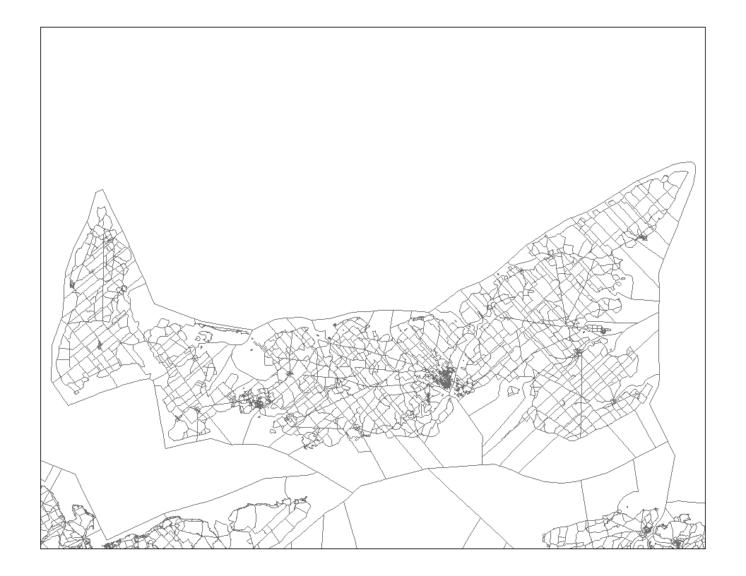
Map 1 Block Digital Boundary File showing detail of Prince Edward Island
The number of blocks and polygons by province / territory are provided below, for the Block Digital Boundary File:

Province / Territory | Blocks | Polygons | Blocks with more than one polygon
Canada | 478,707 | 478,723 | 12
Newfoundland and Labrador | 8,331 | 8,331 | 0
Prince Edward Island | 2,831 | 2,831 | 0
Nova Scotia | 15,161 | 15,161 | 0
New Brunswick | 13,929 | 13,929 | 0
Quebec | 108,760 | 108,765 | 5
Ontario | 128,327 | 128,333 | 4
Manitoba | 30,567 | 30,567 | 0
Saskatchewan | 56,040 | 56,040 | 0
Alberta | 60,061 | 60,061 | 0
British Columbia | 53,147 | 53,152 | 3
Yukon Territory | 674 | 674 | 0
North West Territories | 745 | 745 | 0
Nunavut | 134 | 134 | 0

Please see section 5, Technical specifications, for more details on record layout and file format of the Block Digital Boundary File.

Representative points

A representative point is a single point that represents a linear or areal feature. Representative points for blocks are generated from the National Geographic Base, specifically the road-boundary layer, using the ARC/INFO® Geographic Information System software, which locates the point suitable for label or symbol placement in each polygon.

Special rules apply when a block is in multiple parts, with the point being located in the portion having the largest area. The points are initially generated in metres based on the Lambert Conformal Conic projection—which is the National Geographic Base’s working map projection / coordinate system—and then transformed to and stored in latitude / longitude coordinates (to six decimal places) using the ARC/INFO® Geographic Information System software.

For further information on how to use representative points with the Block Digital Boundary File, please refer to Appendix A.
4. Data quality

Spatial data quality elements provide information on the fitness-for-use of a spatial database by describing why, when and how the data are created, and how accurate the data are. The elements include an overview describing the purpose and usage, as well as specific quality elements reporting on the lineage, positional accuracy, attribute accuracy, logical consistency and completeness. This information is provided to users for all spatial data products disseminated for the census.

Lineage

Describes the history of the spatial data, including descriptions of the source material from which the data were derived, and the methods of derivation. It also contains the dates of the source material, and all transformations involved in producing the final digital files or map products.

Geographic area boundaries were created on the National Geographic Base based on the road network information. Polygon attributes for geographic areas were updated for the 2001 Census on the National Geographic Base road network layer. The geographic area boundaries were based on maps and other information from the census data collection processes or were created automatically by a computer program called Geographic Area Delineation System (GArDS).

The Block Digital Boundary File was created by aggregating small polygons that form blocks in the Road Network File polygon table. Please refer to the Road Network File reference guide (Catalogue no. 92F0157GIE) for additional information on the creation of the Road Network File.

Additional attributes for the creation of custom area files were then added from the Query Base, as listed in the file descriptions and record layouts in section 5. The Query Base is a database maintained within Statistics Canada. The block representative points in latitude / longitude and Lambert Conformal Conic were extracted from the Query Base and added to the polygon file. When blocks comprised more than one polygon, representative points are assigned to the polygon with the largest area. A list of polygons in multiple parts is in the section on logical consistency.

The following steps were taken to derive the Block Digital Boundary File from the Road Network File:

Step 1 Removal of unnecessary road features
The Block Digital Boundary File was derived by aggregating small polygons that form blocks in the Road Network File. Road arcs that were not required to distinguish blocks were removed from the block file (e.g. highway ramps, dirt roads, tracks, logging roads, seasonal roads, etc.). Blocks bounded by these excluded roads are aggregated with adjacent blocks.

The following diagrams illustrate the process for aggregating polygons on the Road Network File to create the Block Digital Boundary File. This first diagram depicts a portion of the Road Network File with attribute information (BLOCKuid) from the Road Network File polygon attribute table. The Road Network File was the primary source of the Block Digital Boundary File. Each polygon represents one polygon on the road network as indicated in Diagram 1. Note that there are multiple polygon blocks.
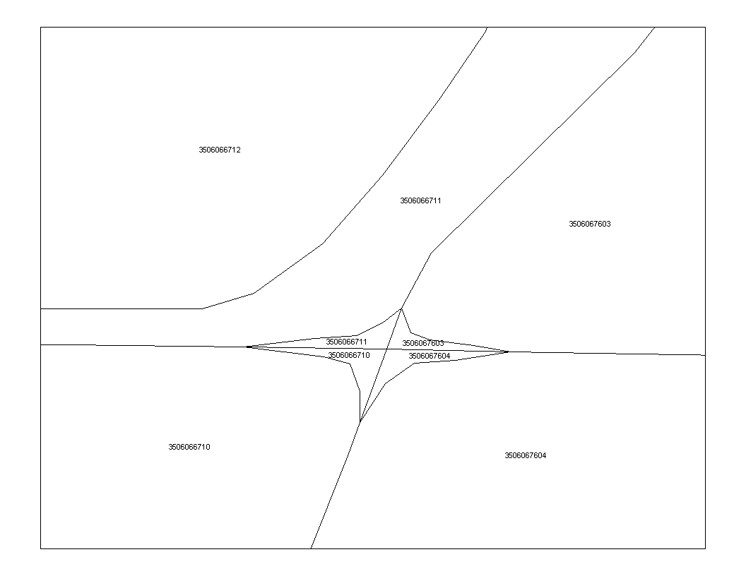
Diagram 1. Road Network File detail showing BLOCKuid labels

All arcs representing certain types of roads not considered useful to Census collection were “dissolved,” or removed. Note that the highway ramps in the example above do not appear in the resulting block boundary file, depicted below.
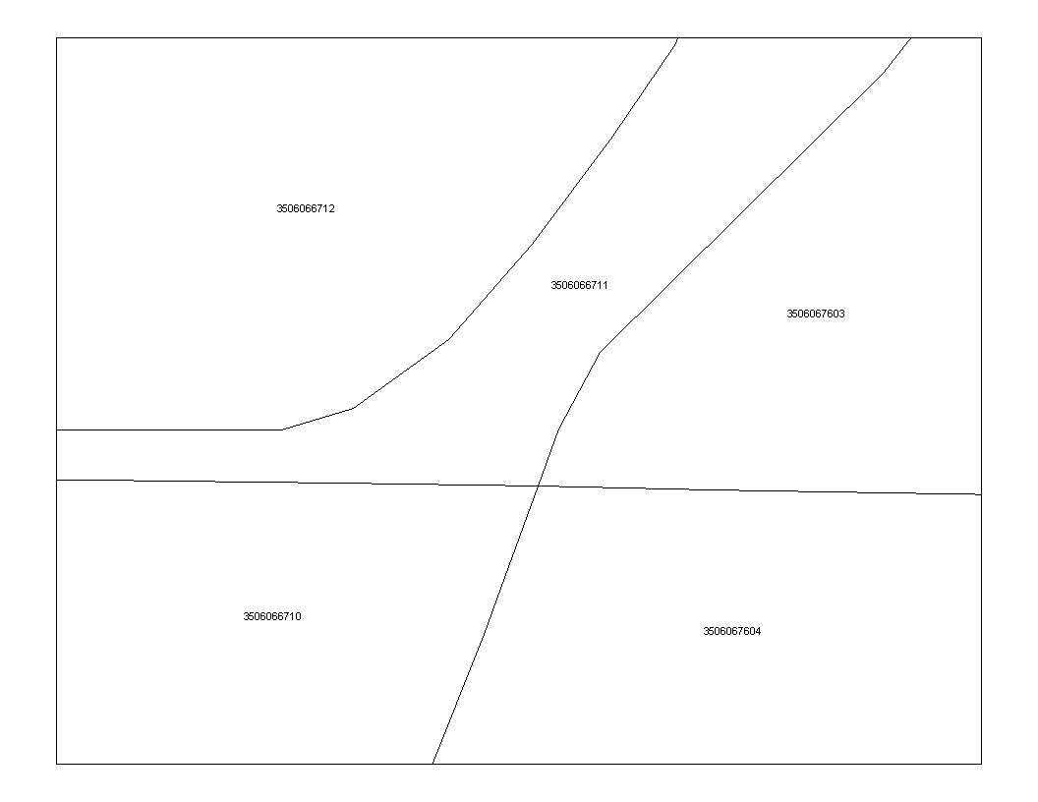
Diagram 2. Block Digital Boundary Network File detail showing BLOCKuid labels
Step 2 Removal of small blocks
The second step eliminates small blocks. Blocks less than 500 square meters in area are aggregated with adjacent blocks.

Step 3 Aggregating blocks (if more than 100 in an EA)
The boundaries of blocks must conform to those of enumeration areas, and any enumeration area with more than 100 blocks is subject to a third step. Each block is ranked according to preset criteria. Blocks having a low rank are aggregated with higher-ranking blocks. There are several cases in which blocks are not contiguous due to limitations in the methodology used to delineate blocks. Please refer to the logical consistency portion of the data quality section (section 4) for more detailed information.

Step 4 Attribute information for the Block Digital Boundary File
Additional information, such as other geographic codes, was then included in the boundary file. This information was derived from the Query Base. The file was quality assured for content, translated from English into French, converted into MapInfo® and appropriately named.

Positional accuracy

Refers to the absolute and relative accuracy of the positions of geographic features. Absolute accuracy is the closeness of the coordinate values in a dataset to values accepted as or being true. Relative accuracy is the closeness of the relative positions of features to their respective relative positions accepted as or being true. Descriptions of positional accuracy include the quality of the final file or product after all transformations.

The positional accuracy of the Block Digital Boundary File is based on the Road Network Files (which are derived from the National Geographic Base). The positional accuracy of the features in the National Geographic Base varies. The data storage precision allows features that are next to each other on the ground to be placed in the correct position on the map, relative to each other, without overlap.

Roads on the National Geographic Base
The positional accuracy of roads on the National Geographic Base varies with the source materials used during creation of the base. An attempt was made to geometrically adjust all roads such that they were in the same position as roads on the National Topographic Database (1:50 000 and 1:250 000) or Digital Chart of the World, which were used for reference purposes. It is therefore expected that these geometrically matched arcs will have a positional accuracy similar to the corresponding reference data used during creation of the database. It should be noted that the reference source selected for different geographic areas depended on a variety of factors such as population size, geographic location (urban or rural) and the availability of National Topographic Database / Digital Chart of the World data in Elections Canada / Statistics Canada holdings and was done on a National Topographic Series tile-by-tile basis. For example, in major urban centres 1:50 000 National Topographic Database data was generally used as the reference data. As a result, in these areas, roads that were geometrically matched will have a positional accuracy similar to roads on 1:50 000 National Topographic Database data. In areas that used 1:250 000 National Topographic Database and Digital Chart of the World reference data the positional accuracy of roads are approximately that of the source data.

The positional accuracy of arcs that could not be matched because they were not present on the reference data is, however, completely unknown. These arcs were digitized from paper maps annotated by field staff. Although highly valuable and accurate in their attribute information and their relative position in relation to other features, the absolute positional accuracy of these roads is of unknown quality.

Other corrections have been made to the National Geographic Base from updated map sheets supplied by local participants for Census and Electoral programs. The positional accuracy of these updates is also of unknown quality. In addition to federal, provincial, and municipal government sources, portions of the National Geographic Base may contain information obtained in part from maps and other materials prepared by private companies. Thus, the National Geographic Base is not suitable for high-precision measurement applications such as engineering problems, property transfers, or other uses that might require highly accurate measurements of the earth's surface.

Quality controls were employed throughout the production process to ensure boundaries were in their correct position relative to the roads on the National Geographic Base.

The representative points on the Block Digital Boundary File were extracted from the Query Base, which in turn uses the representative points extracted from the National Geographic Base’s Road_Geo layer. This layer consists of roads and boundaries and contains no hydrography. The representative points fall in some of the Cartographic Boundary File Dissemination Water file, which includes internal lakes and double-line rivers. Of the 478,707 representative points, 4,341 fall in the dissemination water, 0.91% of the file. It is also likely that additional points may fall into oceans, depending on the scale of the source data and level of detail in its content.

Representative points are not centroids, nor are they weighted to represent population.

Some vertices in the file were removed as a result of minimal line generalization done (based on the Douglas-Peucker algorithm and using ARC/INFO® 8.1) with a weed tolerance of 0.1 metres. The only vertices removed were on straight arcs between nodes. The Block Digital Boundary File is a derivative of the Road Network File, thus it is possible for some arcs to differ slightly from those of the National Geographic Base (a few arcs could have been moved by 1 meter).

Attribute accuracy

Refers to the accuracy of the quantitative and qualitative information attached to each feature (such as population for an urban area, street name, census subdivision name and code).

The attribute data associated with the polygons in the Block Digital Boundary File were independently verified against the data in the Query Base and found to be accurate.

The CMAuid attribute on the block boundary file is a null value outside of census metropolitan areas and census agglomerations. The CTname attribute on the block boundary file is a null value outside of census metropolitan areas and tracted census agglomerations.

Logical consistency

Describes the fidelity of relationships encoded in the data structure of the digital spatial data.

Every polygon was also verified to have a unique identifier for the block: the BLOCKuid. Every case where a polygon did not have a unique BLOCKuid was examined. Some blocks are composed of more than one polygon and form non-contiguous blocks. These blocks are also on the National Geographic Base. The BLOCKuids with multiple polygons are listed below:

2445000403 | 2466306004 | 2483002206 | 2498001506 | 2499000701 | 3520062701
3524028340 | 3524031109 | 3524031118 | 5909025926 | 5915242502 | 5915334101

Every BLOCKuid in the Block Digital Boundary File was verified to be in the Query Base as a BLOCKuid value for the 2001 Census.

Consistency with other products
Previous to the 2001 Census, Digital Boundary Files were available for all levels of geography, at the national, provincial, census metropolitan area and tracted census agglomeration level. For the 2001 Census, the block file is available at only the national level, however, other geographic unit unique identifiers are available on the file to allow for the creation of custom files.

The position of the boundary arcs are generally consistent with those of the Road Network Files and Skeletal Road Network Files. Corrections made to the tolerances in the Road Network Files and the Skeletal Road Network Files may result in differences about of about 1-2 metres between the files. The file is spatially consistent with the Road Network Files and the Skeletal Road Network Files but it does not contain address ranges, road names, types or directions. The file is not consistent with other road networks, external to Statistics Canada, that are positionally accurate.

The Block Digital Boundary File is generally consistent with the Cartographic Boundary Files. However, some of the Cartographic Boundary Files’ boundaries have been modified to follow the shoreline for thematic mapping purposes. Thus, some of the boundaries in the Block Digital Boundary File are not consistent with those in the Cartographic Boundary Files.

Unlike the Cartographic Boundary Files, all boundary arcs in the Block Digital Boundary File are those present in the National Geographic Base. This very detailed information, including boundary arcs that for legal reasons are present in the water, were left as they were depicted in the National Geographic Base. The detailed information was also considered preferable for geocoding with the BLOCKuid information in the Road Network Files.

The attribute information (such as geographic codes and representative points) for each BLOCKuid is consistent with the attribute data found on GeoSuite. The Block Digital Boundary File is suitable for geocoding, as polygons are not subdivided by hydrography.

Completeness

Refers to the degree to which geographic features, their attributes and their relationships are included or omitted in a dataset. It also includes information on selection criteria, definitions used, and other relevant mapping rules.

The number of blocks as well as their unique identifiers were verified against the information in the Query Base. Comparisons were also made with the Road Network Files to determine that representative points are in the correct block.

5. Technical specifications

The national Block Digital Boundary File consists of only one layer of data. There is no hydrographic data included with this file.

File specifications

These are the standard formats in which 2001 Census digital spatial products are available from the Geography Division.

Software formats
All products available on CD-ROM for purchase containing digital boundaries and road network information are available in the following formats:
- ARC/INFO® interchange format version 8.1
ASCII export file
File extension(s): .e00 (spatial and tabular data)
- MapInfo® interchange format version 6.0
ASCII export files
File extension(s): .MIF (graphic data), .MID (tabular data)

Installation instructions
Both the ARC/INFO® and MapInfo® are compressed in self-executable WinZip® files (file extension .EXE). Users can unzip these files by executing them in DOS, or selecting them in Windows® and double clicking on the file icon, or executing them in the RUN dialogue in Windows®.

File names and sizes
File names are formatted in order to better indicate to the client the data source, coverage, geographic area, language and file format of the data.

 | ARC/INFO® |  |  | MapInfo®
 | File name | File size (MB) | File name |  | File size (MB)
Canada (English) | gbl_000d02a_e | 196.1 | gbl_000d02m_e |  | 100
Canada (French) | gbl_000d02a_f | 196.1 | gbl_000d02m_f |  | 100

Geographic representation
This custom product is available in non-projected geographic coordinates (latitude / longitude), using the North American Datum of 1983 (NAD83).

Record layout and file description
Block Digital Boundary File record layout:

The following table shows the format of the attributes contained on the Block Digital Boundary File.

Item Name | Width | Output | Type | Decimals
AREA¹ | 4 | 12 | F | 3
PERIMETER¹ | 4 | 12 | F | 3
<File Name># ¹ | 4 | 5 | B | 0
<File Name>-ID ¹ | 4 | 5 | B | 0
BLOCKuid | 10 | 10 | C | -
DAuid | 8 | 8 | C | -
PRuid | 2 | 2 | C | -
CSDuid | 7 | 7 | C | -
CMAuid | 3 | 3 | C | -
CTname | 7 | 7 | C | -
BLOCKlamx | 4 | 19 | F | 5
BLOCKlamy | 4 | 19 | F | 5
BLOCKlat | 4 | 19 | F | 5
BLOCKlong | 4 | 19 | F | 5
¹ Items included with ARC/INFO® Interchange files only.

Item Description:
Item | Description
AREA | Area of the polygon - maintained by ARC/INFO® (item not included in MapInfo® files).
PERIMETER | Perimeter of the polygon - maintained by ARC/INFO® (item not included in MapInfo® files).
<File Name># | Maintained by ARC/INFO® for internal processing (item not included in MapInfo® files).
<File Name>-ID | Maintained by ARC/INFO® for internal processing (item not included in MapInfo® files).
BLOCKuid | BLOCK unique identifier
DAuid | Uniquely identifies a dissemination area (composed of the 2-digit province or territory code, the 2-digit Census Division code, and the 4-digit DA code).
PRuid | Uniquely identifies a province or territory.
CSDuid | Uniquely identifies a census subdivision (SGC code - composed of the 2-digit province code, the 2-digit census division code and the 3-digit census subdivision code).
CMAuid | Uniquely identifies a census metropolitan area or census agglomeration.
CTname | is the numeric name of the census tract, consisting of 4 digits, a decimal point and two digits. CTs having numbers greater than NNNN.00 are CT splits.
BLOCKlamx | the Lambert Conformal Conic projection x axis coordinate. Together, with the BLOCKlamy it forms the block representative point for the Lambert Conformal Conic projection.
BLOCKlamy | the Lambert Conformal Conic projection y axis coordinate. Together, with the BLOCKlamx it forms the block representative point for the Lambert Conformal Conic projection.
BLOCKlat | the latitude (in degrees and decimals north of the equator) of the block representative point.
BLOCKlong | the longitude (in degrees and decimals west of the prime meridian) of the block representative point.

Appendix A: How to generate representative points

Readers should be aware that the default label points in MapInfo® and ARC/INFO® may not be the same as representative points found in the National Geographic Base. Readers should also be aware that the Block Digital Boundary File is distributed in the non-projected geographic coordinate system, using the NAD83 datum.

This appendix is intended to assist users in the creation of representative points in MapInfo® and ARC/INFO®. This is by no means an official documentation for these software packages because they are not supported by Statistics Canada. It suggests an approach to ensure that the points used in the Block Digital Boundary File for geocoding are those found on the National Geographic Base. For more information regarding the specific software, please contact MapInfo® for MapInfo® technical support or ESRI for ARC/INFO® technical support.

The representative points are included in the Block Digital Boundary File polygon table to enable users to create custom areas. The x and y coordinates are stored in metres with eight decimal points. The representative points are stored as attributes to enable different Geographic Information System software to generate the points.

Generating point files using MapInfo®

The following steps are the same, whether the user is creating the points in geographic coordinate system or in Statistics Canada’s Lambert Conformal Conic projection

- Open the Block Digital Boundary File by clicking File on the menu bar and selecting Open Table option. Navigate to the block table. Select the Block file and click on the Open button.
- Create a new table in dBase format by clicking Table on the menu bar and selecting the Export option. Save the table with a new name and select the save type option dBase DBF [*.dbf] from the drop-down list. Close the original table.
- Open the newly created dBase table by clicking File and selecting the Open Table option. Change Files of type to dBase DBF [*.dbf] (the default is automatically MapInfo [*.tab]). Select to the newly created dBase file and click Open.
- To create points from the dbase file click Table on the menu bar and select the Create Points option.

Steps for geographic points creation:
- For the Get X Coordinates from Column select BLOCKlong
- For the Get Y Coordinates from Column select BLOCKlat
- Click on the Projection button, select Category Statistics Canada and select Category Member Latitude / Longitude (NAD 83), click on OK. Then click on the OK button from the Create Point menu to create point table.
- The point table is now ready for geocoding.

Steps for Statistics Canada’s Lambert Conformal Conic points creation:
- For the Get X Coordinates from Column select BLOCKlamx
- For the Get Y Coordinates from Column select BLOCKlamy
- Click on the Projection button and select the Statistics Canada’s Lambert Conformal Conic in field Category drop-down list and select Longitude / Latitude (NAD 83 for Canada) from field Category Members drop-down list (see footnote 2)
- The point table is now ready for geocoding.

The Block Digital Boundary File contains those fields necessary to create point tables in either the geographic coordinate system or in Statistics Canada’s Lambert Conformal Conic projection.

To create points in other format then use the following procedure:
- Save the newly created point table into another projection system by selecting from the menu bar File → Save Copy As… and then click on the projection button. Select the appropriate projection system and save the table into a new table.
- To get the correct coordinates for the new projection into the table the user must then update the BLOCKlamx and BLOCKlamy columns. Change the column names by selecting Table from the menu bar, navigate to Maintenance and click on Table Structure… option. Select field BLOCKlamx and rename it as CentroidX. Select the field BLOCKlamy and rename it as CentroidY. These field are used for geocoding
- To update the column values, select Table from the menu bar and click on Update Column. Change column to update to CentroidX, and for the Value field, click on the Assist button. Select the Function option and select CentroidX. Click on OK button. Then click on the OK button to update the CentroidX column values. A new Window browser will open verify new CentroidX value.
- Then repeat the calculation for column CentoidY. Select Table from the menu bar and click on Update Column. Change column to update to CentroidY and for the Value field, click on the Assist button, choose function option and select CentroidY. Click on the button OK. Then Click on the OK to update CentroidY column values.
- The point table is now ready for geocoding.

Generating point files using ARC/INFO®

It’s important to note that ARC/INFO® software has a limitation of 100,000 points for creating point files. The Block Digital Boundary File will have to be subdivided into files having less than 100,000 before running the software. Two provinces have more than 100,000 blocks. See table on page 5 for the number of blocks by province / territory.

Steps for geographic points creation:
- Using ArcGIS® 8.x, open ArcToolBox®. Navigate to Conversion Tools, open the Export from Table folder and select Table to Point coverage. ArcToolBox® is the GUI interface which runs ARC/INFO® in the background.
- For the Data Source Type select info table.
- At input X-Y table navigate to the Block Digital Boundary File polygon coverage
- The tool automatically selects BLOCKLAMX as the X-coordinate and BLOCKLAMY as the Y coordinate. Select the geographic coordinates by using the drop-down list to select BLOCKLONG for the X-coordinate and BLOCKLAT for the Y-coordinate.
- In the Output Coverage box, navigate to the folder in which you wish to store the table and type the name of the point coverage.
- The projection must be defined. In ArcToolBox®, navigate to Database Management Tools, open the Projections folder and select the Define Projections Wizard (coverages, grids, TINs).
- Select the ‘Define a coordinate system for my data to match existing data’ option which matches the coordinate system of an existing coverage or grid and select next. For the Dataset navigate to the point coverage, choose the dataset and select next. Select the original Block Digital Boundary File in geographic format to indicate which dataset has the coordinates which the point file requires. Select next and view the summary of your input.
- Once finished the topology of the coverage must be built. Using ArcToolBox®, navigate to Database Management Tools, open the Topology Folder and select Build.
- Select the created point coverage and select the feature class as point.

Steps for Statistics Canada’s Lambert Conformal Conic points creation:
- Using ArcGIS® 8.x, open ArcToolBox®. Navigate to Conversion Tools, open the Export from Table folder and select Table to Point coverage. ArcToolBox® is the GUI interface which runs ARC/INFO® in the background.
- For the Data Source Type select info table.
- At input X-Y table navigate to the Block Digital Boundary File polygon coverage
- The tool automatically selects BLOCKLAMX as the X-coordinate and BLOCKLAMY as the Y coordinate.
- In the Output Coverage box, navigate to the folder in which you wish to store the table and type the name of the point coverage.
- The projection must be defined. In ArcToolBox®, navigate to Database Management Tools, open the Projections folder and select the Define Projections Wizard (coverages, grids, TINs).
- Select the ‘Define a coordinate system for my data to match existing data’ option which matches the coordinate system of an existing coverage or grid and select next. For the Dataset navigate to the point coverage and select next. Select the Block Digital Boundary File which has been converted into Lambert Conformal Conic, using Statistics Canada coordinates to indicate which dataset has the coordinates which the point file requires. Select next and view the summary of your input.
- Once finished the topology of the coverage must be built. Using ArcToolBox®, navigate to Database Management Tools, open the Topology Folder and select Build.
- Select the created point coverage and select the feature class as point.

End-Use Licence Agreement

COPYRIGHT
The Government of Canada (Statistics Canada) is the owner or a licensee of all intellectual property rights (including copyright) in this data product. In consideration of your payment of the requisite fee, you or your organization, as the case may be, (hereinafter referred to as the “licensee”) are granted a non-exclusive, non-assignable and non-transferable licence to use this data product subject to the terms below. This licence is not a sale of any or all of the rights of the owner(s).

TERMS OF USE
- All copyright and proprietary notices and all conditions of use associated with the data product must be communicated to all users of the data product.
- The licensed organisation shall not transfer this data product to or store the data product in any electronic network for use by more than three (3) users unless it obtains prior written permission from Statistics Canada and pays any additional fees.
- The licensee shall not lend, rent, lease, sub-licence, transfer or sell any part of the data product nor any right granted under this agreement to any person outside the licensed organisation or to any other organisation.
- The licensee shall not disassemble, decompile or in any way attempt to reverse engineer any software provided as part of the data product.
- The licensee shall not use any part of the data product to develop or derive any other data product or data service for distribution or commercial sale.
- The licensee is granted reasonable rights of use of the content of this data product only for personal, corporate or public policy research, as well as for educational purposes. This permission includes the use of the content in analyses and the reporting of results and conclusions, including the citation of limited amounts of supporting data extracted from the data product in such documents. In such cases, the source of the data must be acknowledged in all such documents and communications by providing the following source citation at the bottom of each table and graph:
Source (or “Adapted from,” if appropriate): Statistics Canada, name of product, catalogue number of product, reference date of product.
- The Licensee shall obtain approval from Statistics Canada, before publishing any significant volumes of material extracted from the data product in any medium.
- Any violation of this license renders it void and of no effect. This agreement will terminate automatically without notice if the licensee fails to comply with any term of this agreement. In the event of termination, the licensee must immediately return the data product to Statistics Canada or destroy it and certify this destruction in writing to Statistics Canada.

WARRANTIES AND DISCLAIMERS
This data product is provided “as-is”, and Statistics Canada makes no warranty, either express or implied, including but not limited to, warranties of merchantability and fitness for a particular purpose. In no event will Statistics Canada be liable for any direct, special, indirect, consequential or other damages however caused.

ACCEPTANCE OF TERMS
It is YOUR RESPONSIBILITY to ensure that your use of this data product complies with these terms and to seek prior written permission from Statistics Canada for any uses not permitted or not specified in this agreement. Any infringement of Statistics Canada's rights may result in legal action.

ANY USE WHATSOEVER OF THIS DATA PRODUCT SHALL CONSTITUTE YOUR ACCEPTANCE OF THE TERMS OF THIS AGREEMENT.

For further information please contact:
Licensing Services
Marketing Division, Statistics Canada
R.H. Coats Building, 9th floor, section A
Ottawa, Ontario K1A 0T6, Canada
E-mail: licensing@statcan.ca
Telephone: (613) 951-1122
Fax: (613) 951-1134

© Statistics Canada, 2002

GArDS aggregates small geographic areas (in this case, blocks) according to a set of delineating or design criteria to produce a set of desired geographic areas.
2 Statistics Canada’s Lambert Conformal Conic is defined below. Save this as a part of the mapinfow.prj projection file by opening the projection file in a text editor and insert the following text on the top line. Typically the mapinfow.prj file is found in C:\Program Files\Mapinfo\Professional directory. "Lambert (Conformal Conic NAD83)", 3, 74, 7, -91.86666667, 63.390675, 49, 77, 6200000, 3000000
3 Statistics Canada’s Geography Division has it’s own Lambert Conformal Conic projection parameters for it’s National Geographic Base, which is the source of all disseminated spatial data. The parameters are as follows : Projection LAMBERT, Datum NAD83 CNT, Units Meters Parameters 49 0 0.000 /*1st standard parallel 77 0 0.000 /*2nd standard parallel -91 52 0.000 /*central meridian 63 23 26.430 /*latitude of projection’s origin 6200000.00000 /*false easting (meters) 3000000.00000 /*false northing (meters)

