> My results of 2008-09-17 | 

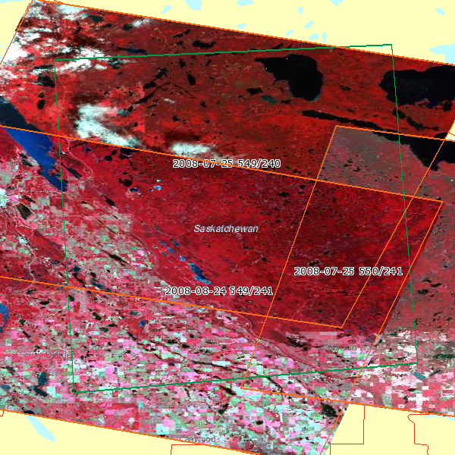
 |  | Area of interest
 |  | Spot scene
 |  | Kompsat-2 scene

Scene reference : 45492400807251819032I 20 m C
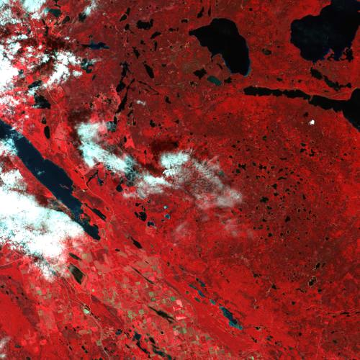 | Satellite : | Spot4
 | K/J : | 549 / 240
 | Acquisition date : | 2008-07-25
 | Cloud % : | 10 %
 | Cloud cover rating : | CBCBDABA
 | Shift along track (SAT) : | 4
 | Centre : | N53°55 W106°40
 | Angle of incidence : | -0.49°
 | Spectral bands : | 4

Scene reference : 55502410807251747131J 10 m C
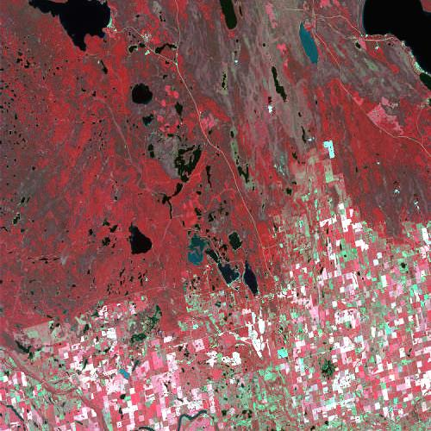 | Satellite : | Spot5
 | K/J : | 550 / 241
 | Acquisition date : | 2008-07-25
 | Cloud % : | 1 %
 | Cloud cover rating : | AAABAAAA
 | Shift along track (SAT) : | 0
 | Centre : | N53°40 W105°53
 | Angle of incidence : | -27.84°
 | Spectral bands : | 4

Scene reference : 55492410808241809482J 10 m C
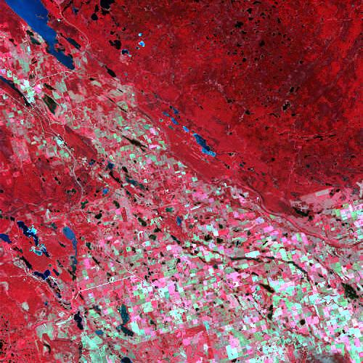 | Satellite : | Spot5
 | K/J : | 549 / 241
 | Acquisition date : | 2008-08-24
 | Cloud % : | 0 %
 | Cloud cover rating : | AAAAAAAA
 | Shift along track (SAT) : | 0
 | Centre : | N53°40 W106°43
 | Angle of incidence : | -4.89°
 | Spectral bands : | 4

